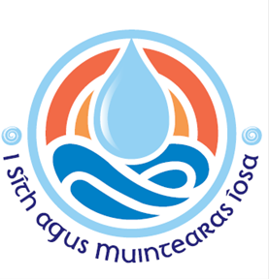
Diocese of Ferns
SAFEGUARDING NEWSLETTER
Spring 2026

Greetings from the Diocesan Safeguarding Office.

Safeguarding in the Diocese of Ferns: Ensuring that our diocese is a safe and welcoming place for our children and vulnerable adults is of utmost importance to our safeguarding team. We encourage our parishes to embrace ministry with children and vulnerable adults. Our role is to ensure that each parish provides a safe environment for children and adults at risk. These are some of the ways to ensure this:
      - Garda Vetting must be renewed every 3 years by everyone who volunteers with children and vulnerable adults
- Safeguarding Training must be renewed every 3 years by everyone who volunteers with children and vulnerable adults. Our trainers play a vital role in spreading the diocesan safeguarding message.
- Risk Assessments must be completed for all activities involving children and vulnerable adults. The location of the activity, the people involved in the activity and the activity itself are all assessed.
- Annual Parish Self-Audit must be completed by each parish to ensure compliance with policies and procedures.
- Parish Safeguarding Representatives: Each parish has a safeguarding rep who, along with their parish priest, is responsible for the implementing of safeguarding policies and procedures in the parish. They are also the person to contact if you have any safeguarding concerns in your parish. The diocese would like to thank all safeguarding reps, present and past, for their contribution to their parish. Thank you for making our diocese a safer place for all those at risk.
- Safeguarding Committee: meet regularly to discuss, monitor, evaluate and advise on all safeguarding policies and procedures for the diocese. They play an integral part in ensuring compliance with NBSCCCI policy and standards.
- National Board for Safeguarding Children in the Catholic Church in Ireland: The NBSCCCI is the governing body for the Catholic Church in Ireland and the Diocese of Ferns must adhere to their policy ‘A Safe and Welcoming Church, Safeguarding Children Policy and Standards for the Catholic Church in Ireland, 2024’.

Safeguarding Information Sessions 2026: The Diocese of Ferns invites all church volunteers to our Safeguarding Information Sessions in 2026. The aim of these sessions is to provide a basic knowledge of how safeguarding works to all those who volunteer with children and vulnerable adults within our parishes. Without your continued dedication to our parishes, activities with children and vulnerable adults would not happen. We also invite those who carry out other volunteer roles and who would like to have more information on how we keep our children and vulnerable adults safe within the diocese. The dates for these sessions are:
- Monday 27th April 2026, Pastoral Centre, Gorey 7-8.30pm
- Thursday 28th May 2026, Talbot Hotel, Wexford, 7-8.30pm
- Wednesday 10th June 2026, Presentation Arts Centre, Enniscorthy, 7-8.30pm
- Tuesday 16th June 2026, Pastoral Centre, New Ross, 7-8.30pm
We are looking forward to meeting with everyone!

Safeguarding Sunday: Sunday 22nd February 2026 is our Sunday dedicated to Safeguarding in the Diocese of Ferns. This is a day to remind our clergy, parish safeguarding reps, volunteers and all others in the parishes that safeguarding must always be foremost in our minds when it comes to activities with children and vulnerable adults. Our policies and procedures must be adhered to in order to create safe environments for all those at risk in our diocese.

Are you interested in volunteering? Would you like to be involved in safeguarding in your parish community? If you think you might be inclined or have any questions to ask, please chat to your priest, parish safeguarding rep, or call Lisa on 053 9174972.
Diocese of Ferns
SAFEGUARDING NEWSLETTER
Spring 2026

Director of Safeguarding & Designated Liaison Person: Lisa Delaney
Tel: 053 9174972 Mob: 087 7185541 Email: safeguarding@ferns.ie
Please contact Lisa if you have any concerns or need to make a disclosure

Deputy Designated Liaison Person: Rev. Brian Broaders
Tel: 053 9255122.


Day of Prayer for Survivors of Abuse
will take place on Friday 20th February 2026

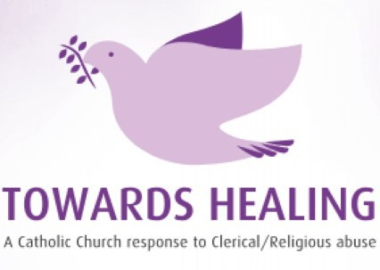

Towards Healing offers a professional counselling service to survivors of clerical/religious abuse
Freephone: 1800 303 416

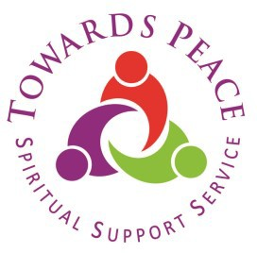
Safe spaces to connect with your own spirituality, with your sense of God and your journey Towards Peace.
Phone: 01 5053028 Mobile: 086 7710533

