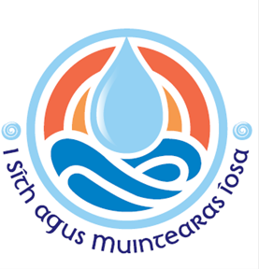
Diocese of Ferns
SAFEGUARDING NEWSLETTER
January 2025

Greetings from the Diocesan Safeguarding Office. It has been a while since our last newsletter; so here are the latest updates.

A Safe and Welcoming Church; Safeguarding Children Policy and Standards for the Catholic Church in Ireland, 2024: The National Board for Safeguarding Children in the Catholic Church in Ireland (NBSCCCI) introduced a new updated policy on 11th June 2024. The new policy condensed 7 standards into 3 new ones: Leadership, Governance & Accountability; Nurturing a Culture of Safeguarding; and Responding Pastorally and Reporting according to Civil and Canon Law. The new policy was welcomed by all in the Diocese of Ferns as it showcases the great work carried out by the NBSCCCI and proves that safeguarding children is always at the forefront of the Catholic Church.

Safeguarding Conference October 2024: On 23rd October 2024, all Clergy and Parish Safeguarding Representatives were invited to the Diocese of Ferns Safeguarding Conference. Lyn McDermott, Director of Training & Support from the NBSCCCI, provided a brief presentation on the new policy. Our new Director of Safeguarding, Lisa Delaney, spoke about the future plans for safeguarding in the diocese. Everyone was encouraged to ask questions which brought about some interesting discussions. Everyone enjoyed a lovely meal together afterwards.

The future of Safeguarding in the Diocese of Ferns:
- Parish Visits: Lisa will continue to support diocesan clergy, parish safeguarding reps and volunteers on the safeguarding journey. This will include visiting parishes to build relationships with the volunteers, to offer advice/support and to ensure best practice.
- Re-training in Safeguarding of all clergy and volunteers will continue every 3 years as advised by the NBSCCCI. All new safeguarding reps and volunteers will be trained before starting in their role.
- Re-vetting of all clergy, safeguarding reps and volunteers is essential every 3 years.
All staff/volunteers who supervise, work with, or interact with children/vulnerable adults must, as part of their role, have completed Garda Vetting before they begin their duties.
- Vulnerable Adult Policy: Our governing body, NBSCCCI, only caters for the safeguarding of children and young people at present. However, we have discovered the need to ensure all adults, who may feel vulnerable or who are at risk, have a specific policy so they can have the best support available by the diocese. This is a work in progress, and we will keep everyone updated.
- Ferns Diocesan Website: The Ferns Diocesan Website www.ferns.ie has all the forms and information needed for those who are in a safeguarding role in the diocese and for anyone who would like to volunteer in the future. It is going through some changes at present, but we are hoping it will be all updated as soon as possible.

Safeguarding Sunday: Sunday 9th February 2025 is our Sunday dedicated to Safeguarding in the Diocese of Ferns. The purpose of this day is to remind our clergy, parish safeguarding reps, volunteers and all others in the parishes that safeguarding is an essential part of our diocese. Policies and procedures are in place to ensure all children/young people/adults at risk, who join in with parish activities and the adults who organise these activities, have a safe environment at all times. Safeguarding is always considered before planning any activity.

Are you interested in volunteering? Would you like to be involved in safeguarding in your parish community? If you think you might be inclined or have any questions to ask, please chat to your priest, parish safeguarding rep, or call Lisa on 053 9174972.
Diocese of Ferns
SAFEGUARDING NEWSLETTER
January 2025

Director of Safeguarding: Lisa Delaney

Tel: 053 9174972
Email: safeguarding@ferns.ie
For out-of-hours concerns/reporting/disclosures, please call Lisa on 087 7185541

Lisa is also the Designated Liaison Person for the Diocese of Ferns.
If Lisa is on leave, Rev. Brian Broaders is the Assistant Designated Liaison Person and can be contacted on 053 9255122.

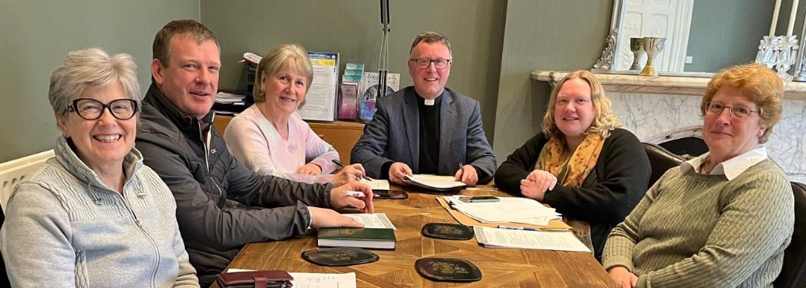
Safeguarding Committee: Eilis Teal, Damien Quigley, Margaret Harper, Rev. Brian Broaders, Lisa Delaney, Eileen Neville and Rev. Aodhán Marken (not pictured) meet regularly to discuss, monitor, evaluate and advise on all safeguarding matters in the diocese. This group is an integral part of safeguarding in the diocese.

Trainers: There are four safeguarding trainers at present in the diocese; Lisa Delaney, Rev. Aodhán Marken, Rev. Gerald O’Leary and Fintan Fanning. These have all received intensive training from the NBSCCCI and receive updates as necessary.

Parish Safeguarding Representatives: Each parish in the diocese has a safeguarding rep who, along with their parish priest, is responsible for the implementing of safeguarding policies and procedures in the parish. They are also the person to contact if you have any safeguarding concerns in your parish. The diocese would like to take this opportunity to thank all safeguarding reps, present and past, for their contribution to their parish. Please know it is greatly appreciated.


Day of Prayer for Survivors of Abuse
will take place on Friday 7th March 2025

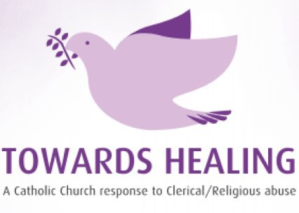
Towards Healing offer a professional counselling service to survivors of clerical/religious abuse
Freephone: 1800 303 416

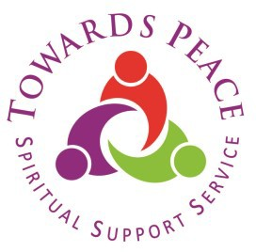
Safe spaces to connect with your own spirituality, with your sense of God and your journey Towards Peace.
Phone: 01 5053028 Mobile: 086 7710533

