SAFEGUARDING HANDBOOK
DIOCESE OF FERNS
2025
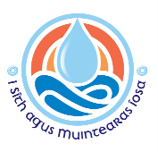

Content | Pages
Section 1 – Garda Vetting & Declaration of Good Standing | 3-5
Section 2 – Parish groups working with children | 6-12
Code of conduct for adults working with children | 6
Code of behaviour for children and young people | 7
Supervision ratios | 8
Dealing with accidents involving children | 9
Complaints procedure | 10
Whistle-blowing procedure | 11
Reporting abuse allegations, suspicions, or concerns | 12
Section 3 – Safeguarding Checklists | 13-19
Parish Priest and Curates | 13
Priests from outside the Diocese, including retired Priests | 13
Priests who intend to engage in once off service | 13
Parish Safeguarding Representatives | 14
Role of Safeguarding Representatives and Parish Priest | 14
Sacristans | 15
Eucharistic Ministers and Home Visitations Teams | 15
Altar Servers | 16
Children’s Choir Groups | 17
Other Parish Activities involving Children/Young People | 18
Parish Volunteers who do not work directly with Children/Young People | 19
Section 4 – Use of Church Property involving Children | 20-21
Parish Groups/Activities | 20
Non-Parish Groups/Activities | 20
Schools using Church property for sacramental celebrations | 21
Section 5 – Diocese of Ferns Website | 22

If you have a safeguarding query please contact:
The Director of Safeguarding
safeguarding@ferns.ie
053 917 4972
If you wish to make a disclosure or report a concern/suspicion/allegation, please call the
Designated Liaison Person at any time, on 087 718 5541

Section 1
Garda Vetting & Declaration of Good Standing

Below are the procedures in relation to vetting requirements.
Garda vetting forms can be found on https://ferns.ie/safeguardingforms/gardavetting/
Garda Vetting
When is vetting required?
A person requires vetting when a necessary and regular part of their work consists of having access to, or contact with, children and/or adults at risk.
Vetting is not necessary when contact with children and/or adults at risk, is merely incidental to their work or activity.
Who requires vetting?
- All Priests ministering in the Diocese.
- Retired Priests who engage in occasional ministry in the Diocese.
- Parish Safeguarding Representatives.
- Persons supervising altar servers.
- Sacristans and those using the sacristy on a regular basis.
- Leaders of groups that involve children/adults at risk.
- Eucharistic Ministers taking the Eucharist to people at home or in care/nursing homes.
- Parish Home Visitation Teams visiting people at home or in care/nursing homes.

How to apply for vetting:
  - Download, print and complete vetting application forms
  - Vetting Invitation Form NVB1 & Guidelines for completion (for applicants who use email)
  - Garda Vetting Form NVB2 & Diocesan Information Form (for applicants who do not have an email address)
  - Vetting Invitation Form NVB3 & Parent/Guardian Consent Form (for applicants under the age of 18)
  - Validation of Identification Checklist

Part 1: Proof of identity
- Bring completed forms along with appropriate identification to your Parish Priest.
- Parish Priest will verify ID and take photocopies.
- Parish Priest will sign and post forms and photocopies of IDs to Diocesan Office.

Part 2: For those who have completed NVB1/NVB3 - Complete email application
- You will receive an email from the Vetting Office, please check your junk mail, occasionally the email will appear here.
- Clink on the link in the email and follow the instructions; you will be asked to enter the following: Place of birth, passport number, mother’s maiden name, and previous addresses.
- Submit your application.

Part 3: Vetting approval
- Once vetting is complete the Diocesan Office will receive a Certificate of Disclosure.
- The disclosure will be sent to the Parish Priest who will store it securely and for as long as is necessary.
- Parish Priest will inform applicant of outcome.
- Applicants must be furnished with a copy of the disclosure from the Parish Priest should they so request it.
- Vetting must be renewed every 3 years for as long as the applicant is carrying out duties in the parish.

Police Clearance:
Any person who is applying for Garda Vetting and has lived outside of Ireland for longer than a year within their lifetime must apply separately to the relevant country for police clearance to prove they have no convictions in that country.

Declaration of Good Standing
Who is required to make a Declaration?
(This declaration is incorporated into the volunteer application form; those not working with children/vulnerable adults, need only complete the declaration)
- All Priests/Volunteers/Staff who are required to fill out a vetting form must also fill in a Declaration Form.
- Readers
- All Eucharistic Ministers
- Collectors
- Committee Members
- Pastoral Council Members
- Flower Arrangers
- Church Housekeeping volunteers/staff
- Community Employment Scheme Participants working on Church grounds
- All other Church volunteers not listed above.

Section 2
Parish Groups Working with Children
Codes of Conduct are essential for effective safeguarding practice.
It is important to carefully read these guidelines and implement them at all times.
The Code of Conduct for the Diocese of Ferns should be displayed within church porches, sacristies, and church halls, and reads as follows:

Code of Conduct for Clergy, Staff & Volunteers Working with Children & Young People

It is important for all personnel to:
- Treat all children and young people with respect and dignity.
- Be visible to others when working with children/young people.
- Clergy, staff and volunteer workers should never plan to be alone in a building, car or a closed room with a child or young person. If one to one contact takes place in an emergency, inform the parent/guardian, and make a written record of the matter (to be given to Parish Priest for secure storage).
- Providing accommodation in the parochial house for minors is prohibited except in the case of family members or children/young people accompanied by parents or guardians. When the need for a visit to the home of a child/young person arises, professional boundaries must be observed at all times.
- Written consent must be obtained from parents/guardians before organising activities for children/young people in your care.
- Particular care should be taken to ensure that the privacy of children/young people is respected in places such as swimming pools, showers, toilets and changing rooms.
- Avoid spending excessive time alone with children/young people, away from others.
- All organised trips require careful planning and adherence to supervision ratios (see page 8 of this handbook).
- Parental consent for taking photographs must always be sought
- Use only age-appropriate language, media products, and activities when working with children and young people. Sexually explicit materials or language are never appropriate.
- Under no circumstances give alcohol, tobacco or drugs to children or young people.
- The physical integrity of children and young people must be respected at all times. Sexual relationships, physical punishments, emotional or verbal abuse are not permitted under any circumstances.
- Ensure that the buildings and/or facilities used for activities with children and young people are suitable, safe, and secure.
Code of Behaviour for Children and Young People

Children should be involved in drawing up a code of behaviour for themselves; however, it is important that in working with children, an appropriate adult with relevant skills and competencies participates to support them in developing the code of behaviour.
The methods used in creating a code of behaviour should be age and ability appropriate, with children being encouraged to avoid merely drawing up a list of prohibitions. Instead, the code should be comprised of positive statements about respect and should consider what consequences ensue if the code is broken.

When developing the code, consideration should be given to the following:

- Treating everyone with respect.
- Treating property with respect.
- Not consuming alcohol, tobacco, or illegal drugs.
- Agreeing not to bring any physical item into the Church activity that may cause offence or harm to others.
- Acting as a good role model.
- Attending activities on time.
- Signing in and out.
- Turning off your mobile phone.
- Telling someone you trust if you feel uncomfortable with any situation or individual.
- Not using bad/inappropriate language in person or when communicating by phone or email.
- Never bullying anyone or sending threatening messages.

Note: Please see leaflet on https://ferns.ie/safeguardingforms/
entitled ‘Safeguarding Brochure Information for Parents’ which provides codes of behaviours for adults and children as well as a copy of the complaints procedure.

Supervision Ratios
In planning an activity or trip, it is critically important to consider how many adults are needed to supervise children in a safe manner. At a minimum, two adults are required, however this is also dependent on whether the children have specific needs or requirements, and on the duration of the activity.
In addition to the initial two adults, the following ratios should be applied:
Within each group the ratio of adults to children is determined by the age of the children involved:
- 0-1 year: one member of staff to three children
- 1-2 years: one member of staff to five children
- 2-3 years: one member of staff to six children
- 3-6 years: one member of staff to eight children
- 7-12 years: one member of staff to eight children
- 13-18 years: one member of staff to ten children

In addition, for overnight activities additional staff should be considered. If the group is mixed, a gender balance should be maintained.

Dealing with Accidents Involving Children

Please see https://ferns.ie/safeguardingforms/
for the ‘Accident/Incident Recording Form’, which provides a template for gathering necessary information, and must be used when such events occur.

If a child has an accident or injures himself/herself while attending a Church-run event, these procedures should be followed:
- Assess the injury and reassure the child. If the injury is severe or the child has lost consciousness, please contact the emergency services by phoning 999.
- If the emergency services are called, immediately inform the child’s parents/guardians. Contact information should be found on the child’s membership/consent form
- If parents/guardians are not available, it may be necessary for a leader to travel with the child to the hospital. If medical treatment is required, Church personnel may be asked about known allergies or existing medical conditions. Again, this information should be found on the child’s membership/consent form
- If the injury is minor, local application of treatment should be available from the first-aid box. There should be a fully stocked first-aid box to hand at all Church-related events. Remember to make a note of what has been used from the first-aid box so that it can be replaced at the earliest opportunity. Under no circumstances should any medication be given to a child, unless under parental or medical supervision
- As soon as possible after the accident, complete the accident/incident report form, referred to above. Once complete, this form should be given to the Parish Priest and stored securely, in line with data protection, and treated as a confidential document
- Always inform parents/guardians of any accident that has occurred involving their child, regardless of how minor you consider it to be. It is good practice to give a copy of the accident/incident report form to parents/guardians
- It is good practice to keep blank copies of the accident/incident form with the first-aid box so that one can be easily filled out in the event of an emergency

Complaints Procedure
A complaint is defined as a grievance and/or the raising of a concern about breaches of codes of behaviour.
Allegations or suspicions of child abuse do not fall into this category of general complaints.
All complaints will be taken seriously and dealt with fairly and confidentially. Efforts will be made to resolve complaints quickly and informally through discussion with the parents/guardians, children/young people, volunteers/members of staff and clergy, as appropriate.
Parents/guardians, young people/children, volunteers, members of staff and clergy will be made aware that there is a complaints procedure.
If a parent/guardian, young person, or child is not satisfied with any aspect of the running of a particular activity, or the behaviour of any individual involved in that activity, the following steps should be taken:
- All complaints of this nature should be resolved using an open dialogue with the person responsible for the group or the Parish Priest.
- If resolution is not possible, the following step should be taken.
Steps to take:
- Complete complaint form and submit to Parish Priest.
- A letter acknowledging receipt of complaint will be sent, enclosing a copy of the complaints procedure (for next steps).
- All complaints must be thoroughly investigated.
- The Parish Priest may organise a meeting, to discuss and hopefully resolve the complaint.
- Following the meeting or discussion, the Parish Priest will write to the complainant to confirm what took place and to set out any solutions that were agreed upon.
- If a meeting is not agreeable or possible, the Parish Priest will issue a detailed written reply to the complainant, setting out their suggestions for resolving the matter.
- If the complainant is still not satisfied at this point, they should contact the Parish Priest again. At the conclusion of this step, the Bishop may decide to take further action on the complaint.

Note: Please see leaflet on https://ferns.ie/safeguardingforms/
entitled ‘Safeguarding Brochure Information for Parents’ which provides codes of behaviours for adults and children as well as a copy of the complaints procedure.

Whistleblowing Procedure

Whistleblowing is defined as ‘raising concerns about wrong-doing or misconduct within an organisation or within an independent structure associated with it’.

All staff and volunteers must acknowledge their individual responsibility to bring matters of concern to the attention of their supervisor/superior/manager.

Reasons for whistleblowing:
- Each individual has a responsibility to raise concerns about unacceptable practice or behaviour
- To prevent the problem worsening or widening
- To protect or reduce risks to others
- To prevent yourself from being implicated

It is important to undertake the following steps:
- Voice any concerns, suspicions or uneasiness as soon as possible. The earlier a concern is expressed the sooner and easier action can be taken.
- Try to pinpoint exactly what practice is of concern and why.
- Approach your immediate superior/supervisor/manager.
- If your concern is about your immediate superior/supervisor/manager, please contact your Parish Priest or the Diocesan Office.
- Concerns should be placed in writing, outlining the background and history, giving names, dates, locations and any other relevant information.
- You are not expected to prove the truth of your complaint, but you need to demonstrate sufficient grounds for concern.
- Make sure a satisfactory response is secured in writing – don’t let matters rest.

Please see https://ferns.ie/safeguardingforms/
for the Whistleblowing guidelines and for the ‘Whistleblowing Record Form’, which must be used when such events occur.

Reporting Abuse: Allegation, Suspicion or Concern
- The Diocese of Ferns provides guidance and training on recognition of abuse, and clear procedures on what to do when a safeguarding concern arises, so that everyone knows how to respond appropriately.
- This involves knowing who to tell and how to record it. It is important that the local reporting procedures are fully consistent with statutory legislation, regulations, and guidance.
- Reporting a concern can be a challenging responsibility. Procedure must be clear about what steps to take to ensure that the safety of children is the paramount consideration.
- The reporting flow chart below refers to any child protection concern, including where the concern is about a situation or person involved in the Church. It is the responsibility of everyone in the Church to ensure that children who may need help and protection are not left at risk of abuse.
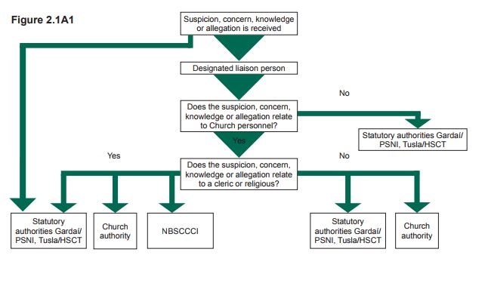

If you wish to make a disclosure or report a concern/suspicion/allegation, please call the
Designated Liaison Person at any time, on 087 718 5541

Section 3
Safeguarding Checklists
This section provides safeguarding checklists for some of the key areas of parish work with children.
All forms & leaflets mentioned in the checklists below are available to download at https://ferns.ie/safeguardingforms/

Priests & Curates
The Parish Priest has overall responsibility for safeguarding children and adults at risk.
In this capacity, the Parish Priest is supported by Parish Safeguarding Representatives and the Director of Safeguarding for the Diocese of Ferns.
Checklist for Parish Priests, Curates & Retired Priests

- Garda Vetting (to be renewed every 3 years)
- Attend Safeguarding Training (to be renewed every 3 years)
- Abide by Code of Conduct for Adults Working with Children and Young People

Visiting Priests: Priests from outside the Diocese, including retired Priests
Checklist for Priests from outside the diocese who intend to minister for short or long periods of time

- Seek permission in writing from Bishop of Ferns; details regarding duration of visit, type of ministry and location of ministry being considered
- Testimonial of Good Standing from own Church Authority sent to Bishop of Ferns
- Garda Vetting (to be renewed every 3 years)
- Attend Safeguarding Training (to be renewed every 3 years)
- Abide by Code of Conduct for Adults Working with Children and Young People

Priests from outside the Diocese: Engaging in once off service
Checklist for Priests who intend to engage in once off service

- This applies to occasions such as weddings, baptisms, and funerals
- Celebret must be viewed and verified by Parish Priest

Parish Safeguarding Representatives
Parish Safeguarding Representatives support the Parish Priest in maintaining safeguarding standards in the Church.
It is recommended that each Parish have two Safeguarding Representatives.
Checklist for safeguarding representatives

- Parish Safeguarding Rep application form, incorporating declaration of good standing and references
- Garda Vetting (to be renewed every 3 years)
- Confidentiality Declaration Form
- Induction with Director of Safeguarding
- Induction Agreement Form
- Attend Safeguarding Training (to be renewed every 3 years)
- Abide by Code of Conduct for Adults Working with Children and Young People

Role of the Safeguarding Representatives and Parish Priest

All Parish Safeguarding Reps must:
Have completed a full day Safeguarding Training Programme (with a refresher session every 3 years).
Be acquainted with the Brochure on the Role of the Rep and familiar with its content.
Receive induction specific to their role.
Complete all relevant safeguarding forms and confirm understanding of same.
Be aware of the safeguarding needs specific to the group setting.
Ensure Garda Vetting is complete and up to date.
Ensure that all parish groups involving children utilise the sign-in/out registers.
Ensure that all non-parish groups fill out the Hall Application Form.
Ensure all Diocesan Safeguarding posters are prominently and appropriately displayed.
Complete Parish Safeguarding self-audit form annually, with Parish Priest.

Sacristans
Checklist for Sacristans

- Volunteer Application Form, incorporating declaration of good standing and references
- Garda Vetting (to be renewed every 3 years)
- Confidentiality Declaration Form
- Induction Agreement Form for Church Volunteers/Personnel
- Attend Safeguarding Information Session Training
- Abide by Code of Conduct for Adults Working with Children and Young People
- Sign In/Out Book in sacristy

Eucharistic Ministers/Home Visitation Teams
Checklist for Eucharistic Ministers/Home Visitation Teams visiting people at home or in care/nursing homes

- Volunteer Application Form, incorporating declaration of good standing and references
- Garda Vetting (to be renewed every 3 years)
- Confidentiality Declaration Form
- Induction Agreement Form for Church Volunteers/Personnel
- Attend Safeguarding Information Session Training
- Abide by Code of Conduct for Adults Working with Children and Young People
- Note details of each visit, e.g., who visited, date and time

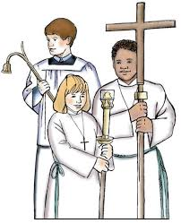
Altar Servers
When is it necessary for Altar Servers to be supervised?
If Altar Servers are required to get ready in a private setting, for example, the sacristy, then supervision is required.
If Altar Servers get ready in public view of the congregation supervision is not required.
Options for the supervision of Altar Servers
As with other supervision ratios two adults should be present, both of whom must be vetted.
- Parents of Altar Servers who have completed diocesan safeguarding checklist below.
- Any adult who has been vetted by the Diocese, e.g., clergy, parish sacristan
- Members of other Church groups who have been vetted.
- Parish Safeguarding Representatives.
Checklist for persons supervising Altar Servers

- Volunteer Application Form, incorporating declaration of good standing and references
- Garda Vetting (to be renewed every 3 years)
- Confidentiality Declaration Form
- Induction Agreement Form for Church Volunteers/Personnel
- Attend Safeguarding Information Session Training
- Abide by Code of Conduct for Adults Working with Children and Young People
- Provide annual information session for parents/guardians & children
- Signing In/Out Book in sacristy

Checklist for parents/guardians of altar serving children

- Child & Parent/Guardian Joint Consent & Media Permission Form
- Young people aware of appropriate Code of Behaviour
- Safeguarding Brochure Information for Parents
- Attend parish information session for parents/guardians and children

Children’s Choir Groups

Who requires vetting for choir groups?
- The leaders of the choir group require vetting.
- The musician accompanying the choir group.
Checklist for Choir Leaders/Musician
- Volunteer Application Form, incorporating declaration of good standing and references
- Garda Vetting (to be renewed every 3 years)
- Confidentiality Declaration Form
- Induction Agreement Form for Church Volunteers/Personnel
- Attend Safeguarding Information Session Training
- Abide by Code of Conduct for Adults Working with Children and Young People
- Attendance Register for Choir
- Provide annual information session for parents/guardians and children

Checklist for parents/guardians whose children are in the Choir

- Child & Parent/Guardian Joint Consent & Media Permission Form
- Young people aware of appropriate Code of Behaviour
- Safeguarding Brochure Information for Parents
- Attend parish choir information session for parents/guardians & children

Mixed Choir (where there are both adult and children choir members)
The leader(s) of the choir group require garda vetting.
All other adult members of the choir are required to make declaration of good standing.

Other Parish Activities involving Children/Young People

Examples of other Parish Activities involving children/young people include:
- Sacramental Preparation Classes
- Children’s Liturgy Groups
- Youth Groups

Checklist for leaders of parish activities involving children/young people:

- Volunteer Application Form, incorporating declaration of good
standing and references
- Garda Vetting (to be renewed every 3 years)
- Confidentiality Declaration Form
- Induction Agreement Form for Church Volunteers/Personnel
- Attend Safeguarding Information Session Training
- Abide by Code of Conduct for Adults Working with Children and Young People
- Abide by Adult/Child Supervision Ratios
- Attendance Register for group
- Provide annual information session for parents/guardians & children

Checklist for parents/guardians whose children/young people are in other parish activities:

- Child & Parent/Guardian Joint Consent & Media Permission Form
- Young people aware of appropriate Code of Behaviour
- Safeguarding Brochure Information for Parents
- Attend parish information session for parents/guardians and children

Parish Volunteers who do not work directly with children/young people

Examples of other Parish Volunteers who do not work directly with children/young people include:
- Readers (who come up from the body of the Church)
- Eucharistic Ministers (who come up from the body of the Church)
- Collectors
- Flower Arrangers
- Church Housekeeping volunteers
- Committee Members
- Pastoral Council Members
- John Paul II Awards Volunteers
- Community Employment Scheme Participants who work on Church grounds

Checklist for Parish Volunteers who do not work directly with children/young people:
- Declaration of Good Standing
- Attend Safeguarding Information Session Training

Section 4
Use of Church Property involving Children

- Parish Groups/Activities:
Parish Activities are carried out with the full knowledge and authority of clergy, or any other person specifically authorised by them. Parish activities within this definition are covered under the parish insurance policy. The responsibility for safeguarding rests with the Parish Priest.
Parish Group Activities must:
- Adhere to the Diocese of Fern’s Safeguarding Policies & Procedures.
- Inform Parish Safeguarding Representative of activities taking place.
- Parish Safeguarding Representative’s role is to assist activity leaders/groups in accessing and adhering to Diocesan Safeguarding Policies

- Non-Parish Groups/Activities:
Any activity, group, class etc. that is not run by or for the parish.
Non-Parish Group/Activities must:
- Complete the Parish Hall Application Form for Non-Parish Activities and renew it annually.
- Have their own separate liability insurance arrangements in place
- Have their own Child Safeguarding Policy in place
- Be approved by the Parish Priest
The Parish Safeguarding Representative has no role in relation to these activities.

Long-term Letting/Leasing Arrangements by Outside Group:
Where all or part of a parish building is let exclusively, for example, to a pre-school or local community organisation, a formal agreement will be in place.
The Parish Safeguarding Representative has no role in relation to these activities.
Long-term lets/leaseholders must:
- Complete the Parish Hall Application Form for Non-Parish Activities and renew it annually.
- Have liability insurance
- Have a Child Safeguarding Policy
- Be approved by the Parish Priest

Parish Priest must ensure:
- Property is fit for use in terms of health and safety
- Groups using the property are aware of how to report accidents arising due to the condition of the property

Private Function
Use of property for private functions (birthday parties for example) is not advised as such functions cannot be covered by parish liability insurance or parish safeguarding protocols.

- Schools using Church property for sacramental celebrations
The school and the parish priest will agree who is responsible for safeguarding for such activities.

Diocese of Ferns Website www.ferns.ie

The Ferns Diocesan website, www.ferns.ie, is kept updated in line with

A Safe and Welcoming Church, Safeguarding Children Policy & Standards for the Catholic Church in Ireland Policy 2024.

This will assist you in your role when working with children.

The Safeguarding Children Policy Document is available to download online on the National Board for Safeguarding Children in the Catholic Church in Ireland’s website.

Please visit the website for easy access to the most frequently
used forms, posters and leaflets.

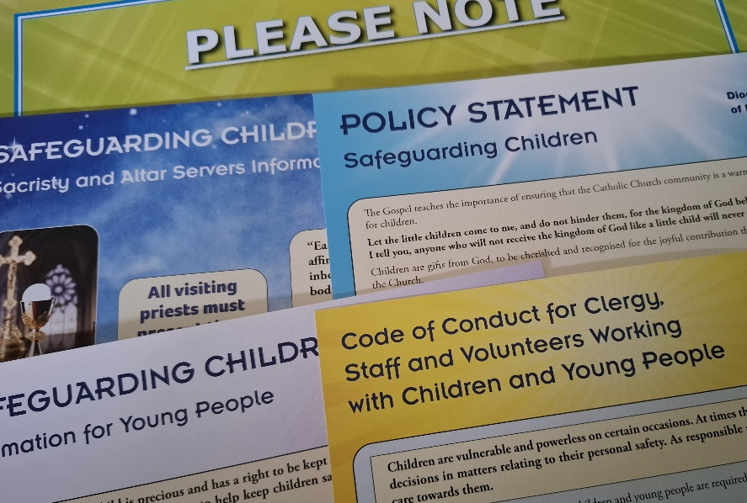

Here you will also find safeguarding newsletters, information on training, the safeguarding committee, and all matters relating to safeguarding in the Diocese of Ferns.

If you have a safeguarding query please contact:
The Director of Safeguarding
safeguarding@ferns.ie
053 917 4972
If you wish to make a disclosure or report a concern/suspicion/allegation, please call the
Designated Liaison Person at any time, on 087 718 5541

