November Remembrance 2021
Which Pope introduced All Saints’ Day?  When was the original date for All Saints’ Day? | Which Pope changed the date of All Saints’ Day to 1st November?  Where did Christian tradition of ‘All Soul’s Day’ begin? | ‘Becoming a Saint’: Place the 5 stages in order  Cannonisation  Proof of ‘heroic virtue’  Wait five years 1  Beautification  Gather evidence
Paschal Candle: Label this candle to outline the significance of each feature for Christians  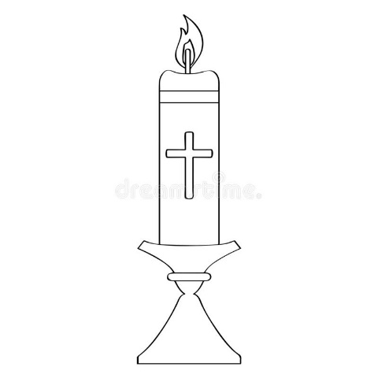 | Patron Saints of:  Teachers  Students  Nurses  Lost items  The environment | Key words:  - Day of Obligation - It has been proved that this person has carried out miracles and is on the way to becoming a saint  - Cannonisation - A day where Christians should go to mass  - Beautification - Praying for someone else  - Intercession - When someone is officially declared a saint  1 2 3 4  B

November a time to remember

