November Remembrance 2021
Which Pope introduced All Saints’ Day? | Which Pope changed the date of All Saints’ Day to 1st November  Where did the tradition of ‘All Saint’s Day; begin? | Patron Saint of  Teachers  Nurses  Carpenters  The Environment  Lost items
List three ways that Christians can remember those who have died | Space to reflect: Who would you like to remember this November? What can you do to remember this person in a special way? | Paschal Candle: What does light represent for Christians?  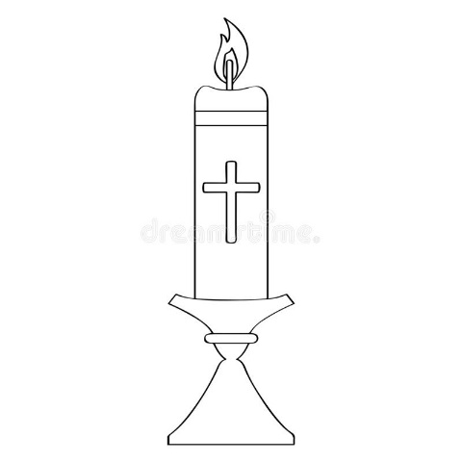

November a time to remember

