Remembrance Resources 2022
Diocese of Limerick

Introduction
The Diocese of Limerick offers this template of a way of remembering our dead during November 2020. Pausing at the end of year, in the month of November, and remembering and honouring or loved ones who have gone before us, is a traditional rite in Irish Catholic life. Please feel free to use and adapt the rituals contained in this brief booklet, as a means for remembering (on your own, or as part of a family or group), the dead of the Diocese.

Home based rituals

Sacred / Prayer Space
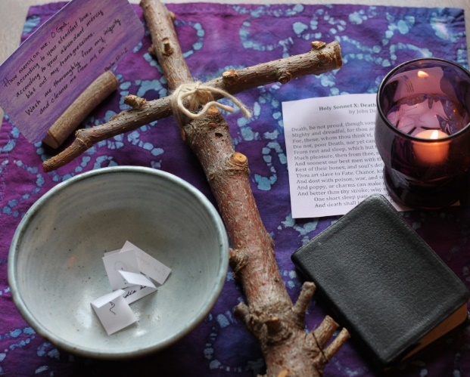
Create a sacred /prayer space / altar in your home for the month of November. Set it up on any surface - the top of a shelf, a mantelpiece, a desk, a shelf that hangs on the wall. It doesn’t have to be perfect and you can always move it later.

Place some religious items on top. You may wish to place a cloth down first, as a way of marking this place out as special for the month. On the altar / sacred space you can place objects that represent your faith such as a Bible, candles, rosaries, statues, crosses, flowers, prayer books, medals, pictures, St Brigid’s Cross etc. One good idea is to display prayers in frames for reading aloud.

At the sacred space, place a bowl containing the memorial cards (or photos) of the deceased / a list of the deceased. During the month, alone or with others, each day take some memorial cards / names on the list to speak their names aloud. This can be done at any time but may be particularly effective at night prayer. Speak one sentence about them; a memory you have of them, what they mean to you, what they symbolise. Finish with a closing prayer along the lines of the following:

Some suggested night prayers:
May the Lord support us all the day long, till the shadows lengthen, and the evening comes, and the busy world is hushed, and the fever of life is over, and our work is done. Then in his mercy may he give us a safe lodging, and a holy rest, and peace at last. – Saint John Henry Newman

As night falls and you look for peace and sleep, forgive what needs to be forgiven with all the love in your heart and soul, and let the day close as it began, with thanksgiving. - Sister Stan

Intentional Prayer
Set aside a specific time each day to intentionally pray for the souls of the dead. Use some of the prayers in this booklet if you wish. Pray that their souls are at peace, that they are in the arms of God, that their sins are forgiven.

Reflective Prayer
- Discernment – explore by one’s self, or with others in the family or group, the bigger picture – our journey to eternal life. Read some of the great teachings in the church on eternity, the end times. Read a reflection here: https://www.archbishopetienne.com/28th-sunday-this-life-is-a-journey-to-eternal-life

- Saint of the Day
Each day, in your sacred place, focus on the Saint of the day, their lives and their reason for sainthood. Ask yourself – what can we learn from this person? See https://www.catholicireland.net/saint-day/ for information of the Saint of the Day.

- Incense – buy some incense and burn some in a small bowl at your sacred space, in front of the bowl of memorial cards / list of the dead. Burning incense is an ancient church ritual and its smell can evoke powerful feelings of closeness to God. Include prayers during the time of burning.

- A Memory Candle

- Praying with a symbol - an Autumn leaf; a leafless branch; a memento of a departed one; a cup of grief; a candle...

- Plant a Bulb/seeds - symbol of life dying in order to come to new life again in Spring

- Reflect on the Seasons of Life - Spring (new life); Summer (living life); Autumn (ageing/change); Winter (death and dying). It’s an ever-ending cycle....be aware of the challenge and the beauty at every stage.

- Autumn Leaves - dry a few Autumn leaves flat. With a felt pen write the name(s) of your deceased loved one(s) on the leaf and place beside a light in the sacred space.

- Read “The Leaves” from Bambi by Felix Saltern:
The leaves were falling from the trees. Two leaves clung on. “It isn’t the way it used to be,” said one leaf to the other. “No, so many of us have fallen off tonight, we’re almost the only two on this branch,” answered the other.
“Even when it is warm and the sun shines, a storm or a cloud burst would come sometimes, and many leaves would be torn off, though they were still young. You never know who is going to go next.” “The sun seldom shines now,” sighed the second leaf. “Soon we will go. Can it be true that we are replaced by others, and then when they have gone by others, more and more?” It is really true,” whispered the other leaf. “It makes me feel very sad. Why must we all fall? What happens to us once we have fallen?” “We sink down...what do you think is under us?” “I don’t know, some say one thing, and some another, but nobody knows. No one has ever come back to tell us about it.” “Which of us will go first?” “Let’s not worry about that now, let’s remember how beautiful it was, how wonderful when the sun came out and shone so warmly that we thought we’d burst with life. Do you remember? “Yes, I remember, but look at me now, I am so yellow and ugly.” “No, you are as lovely as the day that you were born.” Hours passed, a moist wind blew cold and hostile through the branches. The leaves were torn from their places and spun downwards... winter had come.

Cemetery Rituals
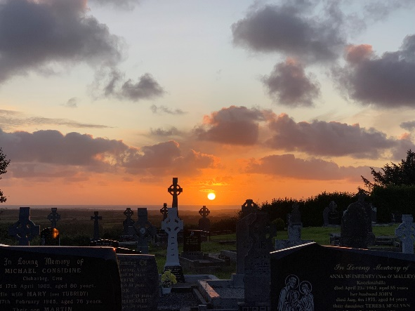
Visit the graves of your loved ones and carry some holy water – sprinkle on each grave and read aloud your favourite prayers / reflections of the dead (see examples later in this booklet for ideas).

Prayer Ritual at Cemetery
‘Praying for and
remembering those we Love’
This is an outline of a possible liturgy that might be helpful to people who visit graveyards in November
Sign of the Cross

Opening Prayer
Lord we come to this holy place to pray for the soul of someone we love and still cherish. Their body lies in the womb of the earth but we trust that their spirits and soul are free and that their love is with us always. We take a moment to remember them and join with them and with each other in silence and prayer…………………………. We make these prayers through Christ our Lord. Amen

Light a Candle
In thanksgiving for the light and love we received in and through ___________ we light this candle and pray a prayer that our ancestors prayed each time they lit a candle:
‘A Shlánaitheoir, go dtuga tú soilse Flaithiúnais dár n-anamacha is na anamacha atá imithe romhainn faoi chomartha an chreideamh’
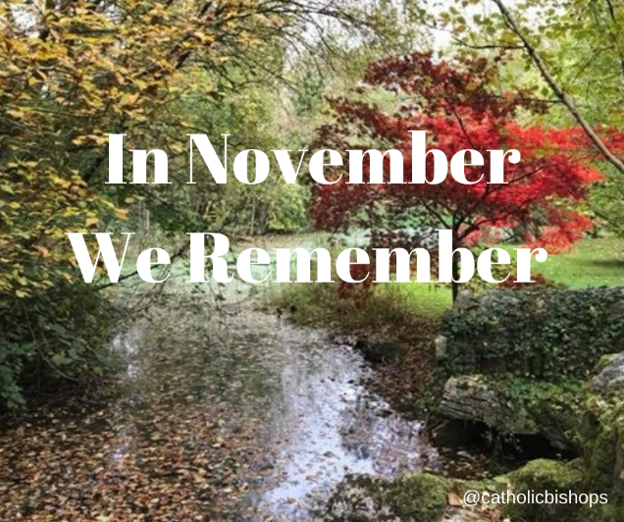
‘Lord, show the light of Heaven to our souls and the souls of those who are gone before us marked with the sign of faith’

Liturgy of the Word
A reading from the book of Wisdom
The souls of the virtuous are in the hands of God, and no torment will ever touch them. In the eyes of the foolish they seemed to have died, and their departure was thought to be a disaster, and their going from us to be their destruction; but they are at peace, their hope is full of immortality. Those who trust in God will understand this truth, and the faithful will abide with him in love, because grace and mercy are upon his holy ones, and he watches over his elect.
The word of the Lord.
A reading from the first letter of St Paul to the Corinthians
Love never ends; as for prophecies, they will pass away; as for tongues, they will cease; as for knowledge, it will pass away. For our knowledge is imperfect and our prophesy is imperfect; but when the perfect comes, the imperfect will pass away. For now we see in a mirror dimly, but then face to face. Now I know in part; then I shall understand fully, even as I have been fully understood. And these three remain, faith, hope and love and the greatest of these is love.
The word of the Lord

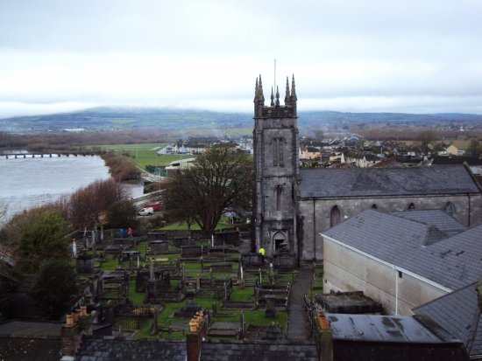
Psalm: see suggestions on pages 6-7.
Sprinkling of Holy Water
Lord, we ask you to bless this grave and draw close our beloved (parent, friend, etc) Because Jesus did not remain in a tomb, we trust that it is the same for …………….
Death may end a life but it never ends a relationships. Give us the grace to trust that __________’s love and light are with us always. May ________’s love continue to affect who we are and what we do. Draw _______ close to you and just as s/he is at peace we pray today for peace and healing for ourselves. We make this prayer through Christ our Lord. Amen

Prayers of the Faithful
Introduction: Lord, we have come on this pilgrimage of prayer in order to keep _______’s flame of love alive in our hearts and lives and so we pray…..
We pray in thanksgiving for the love and joy _______ brought into our hearts and lives. We pray that we will continue to draw strength from his/her goodness to us. Lord hear us

In the midst of the sadness, there is always gratitude for the gift that our loved ones were to us. We praying in thanksgiving for the blessings, light and inspiration we received in and through ___________ . Lord Hear Us

We pray especially each other and family who are at a distance at this time. As we continue to come to terms with the loss of ________, may we find comfort in each other and the fond memories we have of ___________. Lord Hear Us

We pray for the gentle souls of those gone before us. We pray they are at peace with deceased family and friends and may we all one day be reunited in the warmth and light of God’s Kingdom. Lord Hear Us.

We pray for all those who are sick at this time, especially all those who are sick with the virus and those who bravely care for them. We pray for those who are finding things difficult. Lord lead us to healing, to light and to love. Lord Hear us

We pray for all those who are mourning, grieving the loss of the people that they love. It is a difficult time to be grieving, may we try to comfort those who are hurting by finding creative ways of showing our love and care. Lord Hear Us

Possible Reflections – see suggestions on pages 7-8.
Decade of the Rosary:
We pray the mystery of the Resurrection, which is one of the Glorious mysteries. It reminds us that just as Jesus rose from the dead, so it will be for those we love, love never ends.

Our Father, 10 Hail Marys, Glory Be…

Closing Prayer
Lord give us the grace to trust that beyond death there is a life where broken things are fixed, lost things are found, where the weary find rest and where we will all meet again. We ask this through Christ our Lord. Amen

Eternal rest grant unto them O Lord and may perpetual light shine upon them and may they rest in peace. Amen
May their soul and the souls of the faithful departed through the mercy of God rest in peace. Amen
Sign of the Cross

Personal /family local pilgrimage
Walk alone, or with family / group on a personal pilgrimage through your parish, including along the way some stops where you pray for the deceased of a village / street, visit the cemetery, do the stations of the cross along the way, and finish at the church whereby, if open, go in and light a candle for the dead.

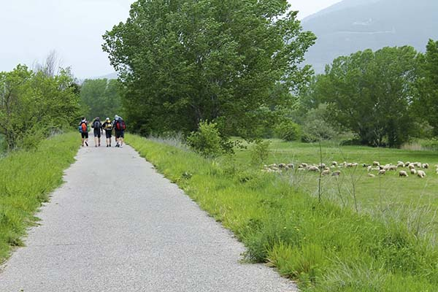

Church based rituals

Prayer Space – set aside a space in the church that is intimate and small, as a Remembrance Space for the month of November. Dress it simply – candles, open bible / prayer book, flowers. Have a sealed box for accepting families List of the Dead.

Prayers
- God, we thank you for the wonderful memories we have of our loved ones. Help us to keep alive these memories in our lives. May our living of these memories help us keep their spirit alive in us, and may the life they lived contribute to the spread of goodness here on earth.

- We turn to you, comforter and sustainer of hope. We entrust all our departed family, relatives and friends to your abiding love, praying for their peace and ours too. With your grace we will surrender as best we can to the mystery of death and what lies beyond it. In You we place our trust.

- Lord, may no harm come to those who have died. May their journey be gentle and their memory blessed. Lighten their way. May they see the glimmer of heaven’s light calling them deeper and deeper into eternal life. May they recognise the kindly faces of loved ones, old friends and neighbours who have gathered to greet them and take them to their eternal home.

- Lord in our empty moments of grief and loneliness may blessed memory be the bridge from our hearts to heaven. May our souls be peaceful till that time when love will call us home.
- The road ahead can seem very long and very dark after the death of a loved one. Often there seems little point in going on. Sometimes the pain and loss can be overwhelming. But God says: Do not be afraid for I shall be with you. Give me faith to trust in your words O Lord.

- Help us to be aware of our neighbours and friends who grieve. May they in time find a new and healed way forward with God at their side.

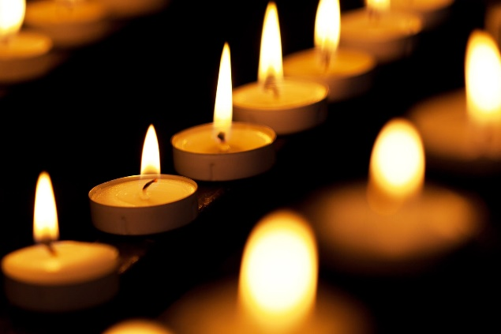
- God, thank you for the special people in our lives whom we remember. We thank you that you are a compassionate God who walks with us in our dark moments of grief and loneliness. We are thankful for all who continue to love and support us through our grief. Continue to be a light for us, giving us hope, direction and courage. May we live our lives treasuring the memories of those special people we have known and loved and help us bring light and hope to others. Amen.

Suggestions on planning Church rituals
- A liturgy can offer more space for creativity. The parish can always celebrate Masses for the dead at other times.
- Have a reader or readers (where safe and possible) and live music.
- Celebrate the ceremony in the evening as you can do more with light and darkness.
- Place an empty chair in front of the altar as the focus to capture the emptiness of loss.
- At a certain point in the liturgy light candles on the seats throughout the church (where you may have names people have sent you – so you see the church fill with light as a piece is sung and possibly people will know that the names they sent in are on a seat somewhere)
- Finally put a candle in the empty chair.
- Encourage people at home to use a candle as part of the ceremony.
- Where possible use images and videos of your local cemeteries (as we cannot gather there for prayers as usual)
- Ensure there is an opportunity for people at home to join in the prayer, be it a decade of the rosary or getting to say an Our Father or eternal rest prayer etc.

Psalms of Comfort and Consolation
Psalm 3
O God, how numerous are my fears!
They rise up within me whispering there is no help for you.
Yet You, O God, radiate love around me; gratitude becomes my song.
When I cry out to you, You answer within my heart.

I lie down to sleep; if I should awaken my God is there holding me with strength and tenderness. I feel secure.
Now I shall forgive all illusions that my ego tries to build.

For my courage is in You, O Lord, You who are the God hidden, hidden in every heart.
Rise up, Lord, set me free!
For through your guidance, my fears will fade into love.
Free from fear, I will know the Oneness of Being that encompasses everything.
I shall be free to serve God with a glad and open heart. Amen.

Psalm 23
O Lord, You are my shepherd, I shall not want; You bring me to green pastures for rest and lead me beside still waters renewing my spirit;

You restore my soul.
You lead me in the path of goodness to follow love’s way.
Even though I walk through the valley of the shadow of death, I am not afraid;
For You are ever with me; your rod and your staff they guide me, they give me strength and comfort.

You prepare a table before me in the presence of all my fears;
You bless me with oil, my cup overflows.
Surely goodness and mercy will follow me all the days of my life;
And I shall dwell in the heart of you O God forever. Amen.

Psalm 71
In You, O my God do I take refuge; Let me never be separated from You!
In Your compassion come and refresh me: Listen to my cry, answer my plea!
Be to me a rock, a tower of strength, a strong arm to uphold me, as I abandon myself into Your hands.
Be a presence to me when fear grips me, as I grow old and my friends leave me.
For You, O Friend, are my hope, my strength, since I was a child.
Upon You have I trusted from my birth, You whom I knew before I was born.
I have been a burden to many; now in You alone will I trust.
I am filled with gratitude and sing your praise all the day.
Do not abandon me when my strength is spent.
O God, be not far from me; come and enfold me in your presence. Help me to release my fears.
Hear my prayer that these fears may be transformed.
I surrender myself into Your hands, as I grow in inner peace and serenity.
I praise You in the silence of my heart for Your steadfast love.
I offer my prayers out to others, extending Your love of abounding grace and kindness.
I will continue to live in peace. Amen

Psalm 142
I call to You from the depths of my being, with a loud voice I cry out to You!
I pour out my fears before You, I confess the doubts that I have within.

When I am weary and my heart faint, You are my Rock!
In the paths where I walk, is it not You who knocks at the gate of my heart?

And are You not the voice of mercy comforting me in times of trouble?
Yes, your Presence washes over me, like the ocean lapping on the shore.

I call to You O God, for You are my refuge.
Come to me in the silence, drop pearls of wisdom into my heart.
Forgive me for every unkind word and thought.

Release me from the prison of fear that I might rejoice and offer thanksgiving.
Transform my weakness into new life, that I may be a gift of Your love to all I meet. Amen.

Reflections

Grief (John O’Donoghue)
Though the silent weeping of your heart lessens, you get on
More or less, with your life;
A place is kept with you, the one who is gone.
No other will ever be given the key to that door.
As the years go on you may not remember the departed
Every day in your conscious mind,
Yet below you surface mind,
Some part of you is always in their presence.
From their side, our friends in the unseen world are always
Secretly embracing us in their new and bright belongings.
Though we may forget them, they can never forget us;
Their secret embrace unknowingly shelters and minds us.
The bright moment in grief is when the sore absence
Gradually changes into a well of presence.
You become aware of the subtle companionship
Of the departed one.
You know that when you are in trouble,
You can turn to this presence beside you and draw on it
For encouragement and blessing.
The departed is now no longer restricted
To any one place and can be with you any place you are.
It is good to know the blessing of this presence.

On the Death of a Loved One
Though we need to weep your loss
You dwell in the safe places in our hearts
Where no storm or night or pain can reach you.
Your love was like the dawn
Brightening over our lives,
Awakening beneath the dark.
Your spirit here was alive, awake, complete.
Let us not look only for you in memory
Where we grow lonely without you.
You would want us to find you in presence
Beside us when beauty brightens
When kindness glows.
When darkest Winter has turned to Spring.
May this dark grief flower with hope
In every heart that loves you.
May you continue to inspire us.
To enter each day with a generous heart.
To serve the call of courage and love
Until we see your face again
In the land where there is no more separation.
Where all tears will be wiped from our mind,
And where we will never lose you again.

We Remember them
In the rising of the sun and it’s going down,
In the blowing of the wind and the chill of winter,
In the opening of the buds and in the rebirth of spring
In the rusting of leaves and in the beauty of autumn, we remember them.

In the beginning of the year and when it ends
When we are weary and in need of strength,
When we are lost and sick of heart,
When we have joys and special celebrations we yearn to share, we remember them.

So long as we live, they too shall live, for we are part of them.
When we sing God’s praises, we remember them.

Seashore
“I am standing upon the seashore. A ship at my side spreads her white sails to the morning breeze and starts for the blue ocean”
She is an object of beauty and strength. I stand and watch her till at length she hangs like a speck of white cloud just where the sea and sky come to mingle with each other.
Then, someone at my side says: “There, she is gone!” “Gone where?” Gone from my sight. That is all.

She is just as large in mast and hull and spar as she was when she left my side and she is just as able to bear her load of living freight to her destined port.
Her diminished size is in me, not her.
And just at that moment when someone at my side says,” There, she is gone”
There are other eyes watching her coming, and other voices ready to take up the glad shout: “Here she comes!”
And that is dying.
Every Day
Every day I need you Lord, but this day especially, I need some extra strength, to face whatever is to be.
This day more than any day, I need to feel you near, To fortify my courage and to overcome my fear.
By myself, I cannot meet the challenge of the hour, There are times when humans help, but we need a higher power
To assist us bear what must be borne, and so dear Lord, I pray - Hold on to my trembling hand and be near me today.

In Time of Sorrow
May you see God's light on the path ahead
When the road you walk is dark, may you always hear even in your hour of sorrow
The gentle singing of the lark
When times are hard may hardness
Never turn your heart to stone
May you always remember when the shadows fall
That you do not walk alone.

Then you must not grieve so sorely, for I love you dearly still:
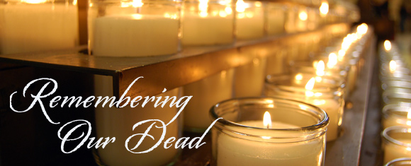
Try to look beyond earth’s shadows, pray to trust our Father’s will.
There is work still waiting for you, so you must not idly stand;
Do it now, while life remaineth, you shall rest in Jesus’ land.
When that work is all completed, he will gently call you home;
Oh the rapture of that meeting, oh the joy to see you come!

They’re in the sun
They’re in the sun, the wind, the rain,
They’re in the joy and they’re in the pain.
They’re in the air you breathe each day,
They’re love is near, it’s here to stay.
They sings their songs of hope and cheer,
they’re free from pain, and free from fear.
You’ll see them in the clouds above,
you’ll hear them whisper words of love.
You’ll be together, when your time is done,
Until then, may you hear their song.

Liturgy of the Word Templates
The National Centre for Liturgy has prepared Liturgy Resources for the month of November remembering relatives and friends of all who have died and in particular, those who have died this year from Covid-19.
The resources can be used in schools, homes or online. These resources can be downloaded from their website:
http://www.liturgy-ireland.ie/

Recommended Reading / Viewing
- Psalms for Praying, Nancy Merrill
- Benedictus, John O’Donohue
- The Celtic Way of Prayer, Esther De Waal
- St Francis Hospice Teenage Book on Grief: Please let me know and I will email this to you. dermot.cowhey@limerick diocese.org

