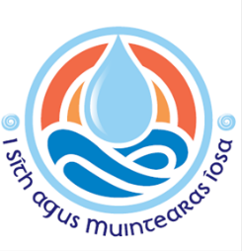
Diocese of Ferns
Response to Patsy McGarry
Re allegations of child sexual abuse at St Peter’s College and other schools in the diocese.
February 2023

St. Peter’s College, Wexford, comprised of a boarding school, secondary school and seminary, during the time concerning the allegations.
Allegations of child sexual abuse were made against 3 priests concerning their time as teachers of students at St. Peter’s, from the early 1960’s to the early 1990’s.
All allegations concerning these priests were reported to the civil authorities.
1 priest was prosecuted and convicted in the criminal courts. This priest was also sanctioned by the Church and was laicised.
Another priest was sanctioned by the Church and was laicised.
1 priest was deceased at the time the allegation was made.
12 settlements were paid by the diocese to individuals who had made allegations of abuse concerning their time at St. Peter’s College.

The diocese received 5 allegations of child sexual abuse concerning 2 priests at other schools in the diocese.
All allegations were reported to the civil authorities.
Settlements were paid in respect of three of these allegations.

