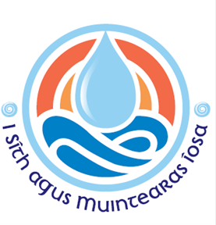

Dear Father and Parish Safeguarding Rep,

As instructed by the National Board and The Children First Act 2015 (part 2, article 1), the attached risk assessment form should be completed for all activities that take place in your parish, that involve or may involve children and vulnerable adults.

Activities such as: altar serving, choir, catechesis, Christmas plays etc.

From a safeguarding perspective, many of the risks for such activities will be the same, such as: risk of physical/bodily/psychological harm, not having enough garda vetted adults per number of participants, lone working (eucharistic ministers visiting private residences for example) etc.

This means that once one form is complete, the rest may be fairly simple and repetitive, so please pay
attention to each one individually to ensure all risks are accounted for.

Please refer to Standard 1, indicator 1.7 in the safeguarding standards book or on the NBSCCCI website, www.safeguarding.ie for more detailed information and guidance on this subject.

You may also find the Diocese of Ferns Child Safeguarding Statement helpful. This is available on the Diocesan website www.ferns.ie under the safeguarding tab.

If you have any queries or would like help filling out the forms, please get in touch in one of the following ways:

Call me on 053 917 4972 or 087 718 5541

Or email safeguarding@ferns.ie

Many thanks for all your help.

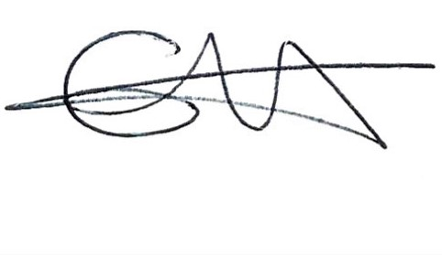
Emma Fitzgerald │Director of Safeguarding │Diocese of Ferns

Diocese of Ferns

Guidelines for completing Risk Assessments for Parish Groups/Activities

All parish activities/groups involving children/vulnerable adults now require risk assessment

- Risk assessment is an aid to understanding the needs of a group from a safeguarding perspective, and a tool to help identify the appropriate safeguards required (and who is responsible) in order to establish the proposed activity.

- The risk assessment is a working document that should be reviewed and changed/updated when the need arises and, in any case, at least once a year from the date the document is signed.

- This document should be discussed and completed by the group/activity leaders, parish safeguarding rep, parish priest, or a combination thereof.

- This template is designed to be simple, please see the sample risk assessment below.

SAMPLE
Name of Church/Parish: St. Mary Immaculate_______________________________________________________________________ Name of Group/Activity: Altar Servers________________________________________________________________________________ Date of risk assessment: 7th November 2022 ________________________ Review due: November 2023 ____________________ Person completing assessment: Joseph Carpenter ____________________ Role: Safeguarding Rep ______________________
Others attending planning meeting: Peter Fisher (sacristan) & Fr. John Baptiste (parish priest) ___________________
Identified risks | Controls/procedures in place to manage risk | Persons responsible
Abuse (verbal, psychological, physical, sexual) by those in charge of children | - Garda Vetting of adults (before commencing in role) in charge of supervising altar servers  - At least 2 vetted adults to be present in the sacristy with children  - Sign in book to be used by everyone (including servers) entering the sacristy to perform duties  - Doors to remain open at all times while children are in sacristy/vestry  - Priest, sacristan, and other adults will not be alone with children  - Code of conduct and policy statement to be visible in sacristy  - Safeguarding training undertaken by priest, safeguarding rep, and altar server supervisor | - Safeguarding rep & parish priest  - Sacristan, priest, and person supervising servers  - Safeguarding rep, priest and all who use sacristy  - Sacristan, priest, and person supervising servers  - Sacristan, priest, and person supervising servers  - Safeguarding Rep and priest  - Safeguarding rep, priest, and director of safeguarding for diocese

Standard 1
Creating and Maintaining Safe Environments
Guidance for Indicator 1.8
Risk Assessment Form
This form will be held in accordance with the data protection policy of the Diocese of Ferns.
The data entered will be used only for the purposes indicated on the form.
This risk assessment is part of the child safeguarding statement which can be accessed here https://ferns.ie/policyandstandards/
This risk assessment seeks to identify any potential for harm, as defined in the Children First Act 2015, to a child while participating in activities organised by a Church/Parish in the Diocese of Ferns, and to ensure that adequate procedures are in place to manage identified risks.

It will be reviewed at least annually or as soon as practicable after there has been a new risk identified or any other relevant change.

‘Risk’ in the context of this risk assessment is the risk of harm to children as defined in the Children First Act 2015

Name of Church/Parish _______________________________________________________________________________________________________________ Name of Group/Activity________________________________________________________________________________________________________________ Date of risk assessment _____________________________________________ Date of review ______________________________________________ Person completing assessment ________________________________________ Role ______________________________________________________ Others attending planning meeting ______________________________________________________________
__________________________________________________________________________________________________________________________________________________________________________________________________________________________________________________________________________________________________

Risk Assessment Form Continued
Must be kept with front page

Identified risks | Controls/procedures in place to manage risk | Persons responsible

Risk Assessment Form Continued
Must be kept with front page

Identified risks | Controls/procedures in place to manage risk | Persons responsible

