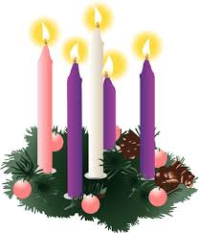
Advent Poetry Worksheet

Poem:
Writer:

What is your personal opinion of this poem?

What aspects of Advent are conveyed in this poem?

How could poetry help in your preparation for Christmas?

Can you list any other poems you know that deal with Advent or Christmas?

