SPIRIT DIOCESAN YOUTH GROUP APPLICANT FORM

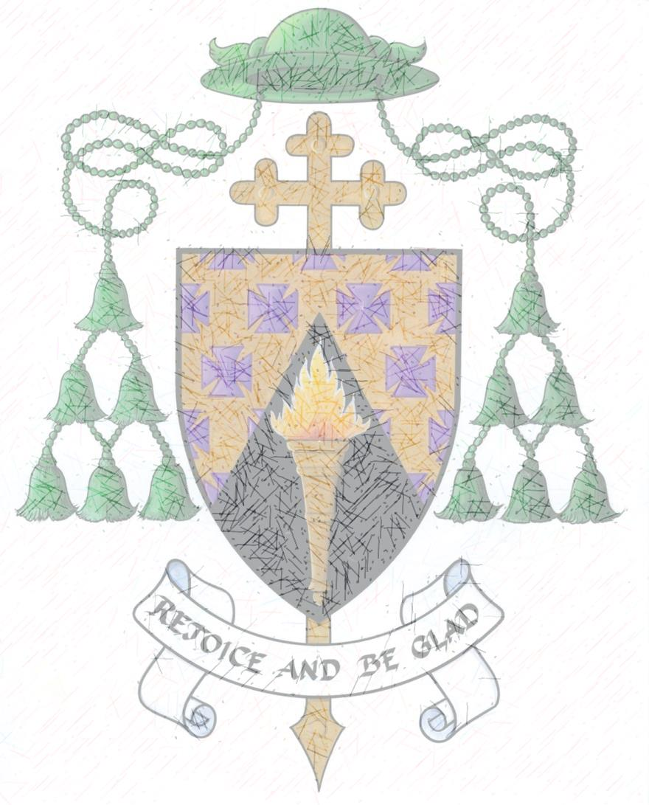

Details about the Group
Name of Group | Spirit Youth Group – See Brochure
Duration/Frequency of activity: | October – May with weekly workgroups and meetings.
Name of Organiser: | Colette O’Doherty; Safeguarding Co-ordinator

Details of the young person:
Name of Young Person:
Address:
Date of Birth:
Gender (please tick) | Male Female
Name of School attending:
What class/year are you in?
Contact information of young person (for emergency use only)

Why do you want to join Spirit?
_______________________________________________________________________________
_______________________________________________________________________________
What workgroup would you like to be in?
_______________________________________________________________________________
_______________________________________________________________________________
Guardian Contact Details
Name:
Daytime phone number: | Code__________ Local No:____________________
Home phone number: | Code__________ Local No:____________________
Mobile Number:
Email

Other relevant information:
(Please mention any medical conditions, special needs or dietary requirements of young person).
Please note that the organisers cannot administer any medication. Should medication or special care be required, please discuss this with the organisers who will work with you to establish how your child can be accommodated, according to relevant policies and procedures.
_______________________________________________________________________________
_______________________________________________________________________________
_______________________________________________________________________________

In cases of a Medical Emergency
In the event of illness or accident, I give permission for medical treatment to be administered to my child where considered necessary by a suitably qualified medical practitioner and/or hospital. I understand that every effort will be made to contact me as soon as possible. In an emergency I can be contacted at the telephone numbers provided on the previous page.

Signed:_______________________________________________

Young Person’s Consent

I________________________________________ (Insert first name and surname) would like to take part in the event listed above.

(If relevant please tick the boxes below)

I understand that during the group activities photographs may be taken and I give my permission for these to be used in any hard copy/online (delete as appropriate) publications by the Diocese of Ferns.

I understand that during the group activities videos (which may include webcam) may be taken and I give my permission for these to be used in any hard copy/online (delete as appropriate) publications by the Diocese of Ferns.

I understand that at the group activities I will be appropriately supervised at all times.

Guardian’s Consent
I agree to allow the young person named above to attend this meeting on the (insert date)__________, from (insert start time)_____________ until (insert end time) ____________, in accordance with the permission granted by ______________________(insert name of young person) above. I understand that there will be suitable supervision while the young people are in the care of the organisers.

Signed:__________________________ Name (block letters)______________________________
Guardian Guardian

Relationship to Young Person:_______________________________________________________

Signed:__________________________ Name (block letters)______________________________
Young Person Young Person

Data Protection
This form will be held on file in accordance with the Data Protection Policy of the Diocese of Ferns. The data entered will be used only for the purpose indicated on the form. It may be accessed only by those with responsibility for managing records or group activities.

