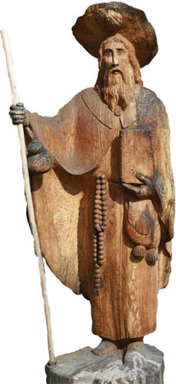
Camino Walk

From

Our Lady’s Island
to
Tomhaggard Village
on
Saturday July 25th 2015

Commencing at about 3pm with a walk around the island then travelling to Tomhaggard via Tacumshane.

The pilgrim walk will conclude with Mass at 7.30pm in St. James’ Church, Tomhaggard.

This walk is being organised by Ferns Youth Ministry as part of preparations for the Camino walk in Spain in August 2015 and World Youth Day in Poland in 2016 but it is open to all pilgrims.



