To mark his Beatification on Saturday 23rd May  Ferns C.A.F.E  PRESENTS  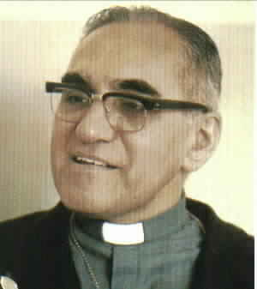  ROMERO  A MOVING AND POWERFUL FILM THAT TELLS THE LIFE OF OSCAR ROMERO  ARCHBISHOP OF EL SALVADOR, KILLED FOR HIS FAITH ON 24TH MARCH 1980  ‘ROMERO: AN UNWLLING HERO WHO WAS FORCED BY HIS CONSCIENCE TO SPEAK OUT FOR THOSE TOO FRIGHTENED TO SPEAK FOR THEMSELVES’. Minnieapolis Star Tribune  Riverside Park Hotel  Tuesday 19th May 2015 at 7.30pm.  All Welcome |  |  | PROPHETS OF A FUTURE NOT OUR OWN  It helps, now and then, to step back and take a long view. The kingdom is not only beyond our efforts, it is even beyond our vision. We accomplish in our lifetime only a tiny fraction of the magnificent enterprise that is God's work. Nothing we do is complete, which is a way of saying that the Kingdom always lies beyond us.  No statement says all that could be said.  No prayer fully expresses our faith.  No confession brings perfection.  No pastoral visit brings wholeness.  No program accomplishes the Church's mission.  No set of goals and objectives includes everything. This is what we are about.  We plant the seeds that one day will grow. We water seeds already planted, knowing that they hold future promise. We lay foundations that will need further development.  We provide yeast that produces far beyond our capabilities. We cannot do everything, and there is a sense of liberation in realizing that.  This enables us to do something, and to do it very well. It may be incomplete, but it is a beginning, a step along the way, an opportunity for the Lord's grace to enter and do the rest.  We may never see the end results, but that is the difference between the master builder and the worker. We are workers, not master builders; ministers, not messiahs  We are prophets of a future not our own.  ARCHBISHOP OSCAR ROMERO

