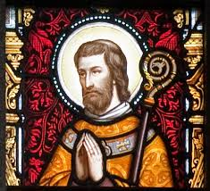

**Gathering on**

**THE FEAST OF ST AIDAN**

**Pray for Vocations to The Priesthood**

**St. Aidans Cathedral**

**Thursday 30th January at 7.30pm**