Some points from the “Transformed Parish” Conference
Maynooth November 27th 2017
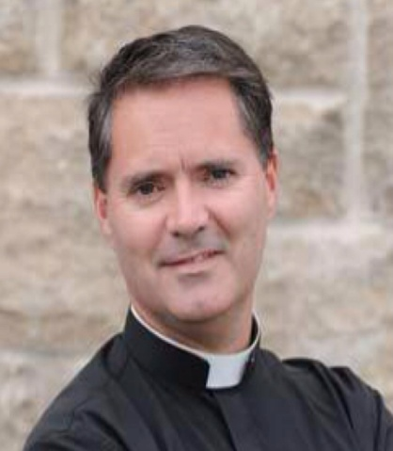
In his presentation, Fr. James Mallon offered a blueprint for parishes to go beyond maintaining their buildings and meeting the needs of their parishioners. He believes the key to being a Church that is alive and relevant is for parishes to embrace their mission, which is to make disciples.
He quoted Pope Francis who said “I dream of a missionary option, a missionary impulse, capable of transforming everything so that the church’s customs, ways of doing things, times and schedules, language and structures can be suitably channelled for the evangelisation of today’s world rather than self-preservation.”
He is here challenging parishes to change from maintenance to mission.
Change is necessary to survive
Fr. Mallon gave some examples of Companies that failed because they were more attached to traditional ways of doing things rather that change eg. Swiss watches v digital watches. Because they were blind to change happening outside their organisation they didn’t adapt and became failed entities. Kodak failed to change from manufacturing films and cameras and was overtaken by digital cameras and smart phones and finally became bankrupt. Fr. Mallon declared that when the change outside an organisation is greater than that taking place within, the organisation becomes irrelevant!
He outlined the 6 Stages involved in not dealing with change
- Denial, no one is concerned and impact is negligible.
- Recalibration, where there is recognition that something is wrong but the solution is seen as doubling energy on a losing strategy or search for a “magic bullet” but there is no desire for deep change.
- Anger, stemming from the realisation that recalibration isn’t working, the blame game begins. We blame young people, bishops, media, culture...
- Exodus ,where the outflow from the organisation (in this case the church), continues and churches are deserted.
- Desperation. Those remaining say they are open to change and new ideas but this is more in desperation than from conviction.
- Death occurs and church buildings are sold.

16% of bishops, priests and parishioners are open to risk ie. Innovators and Early Adopters (above left)
The middle 68% of bishops, priests and parishioners are slow coming to change.
16% of bishops, priests and parishioners at the other end are consistently against everything to do with change.
For change to happen it is vital to identify and work with the 16% of Innovators and Early Adopters

What is the Mission of the church?

It is based on Matthew 28: 19- 20
¹⁹ Therefore go and make disciples of all nations, baptising them in the name of the Father and of the Son and of the Holy Spirit, ²⁰ and teaching them to obey everything I have commanded you. And surely I am with you always, to the very end of the age.”
We baptise and teach but do we make disciples, evangelise?
We sacramentalise and catechise and because we believe we are only called to baptise and teach. We have forgotten Christ’s primary injunction- Make disciples

Formation of a Missionary rather that maintenance model of church
- Encounter with Jesus Christ, constantly renewed by personal testimonies and the proclamation of the Gospel
- Conversion ,an initial response to belief in Jesus, a decision to become his friend
- Discipleship, constantly maturing in knowledge, ongoing catechesis
- Communion, celebration of the sacraments.
- Mission, inseparable from discipleship
Fr. Mallon used the Alpha Programme to move his parish from maintenance to mission

