Called and Gifted.
By Bishop Denis Brennan

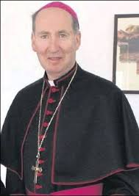

Over fifty years ago Vat.11 published the Decree on the Apostolate of the Laity. I would like to quote two lines from it;

“Lord sends them on the Church's apostolate, an apostolate that is one, yet has different forms and methods, an apostolate that must all the time be adapting itself to the needs of the moment."
Some years ago the American Bishops published a Reflection on the Decree entitled' Called and Gifted,' acknowledging the new understanding of the role of the laity, ushered in by Vat.11.
As people study the Scriptures, participate in the music ministry, study theology, work in soup kitchens and shelters, they are touched in mind and spirit.
All these actions when performed in the name of Jesus and enacted under the aegis of the Church, are forms of ministry.
Allowing for the difference between the States and here this is what you are doing in your own involvement in the life of the Church. What you do in your PPC's is the apostolate Vat.11 spoke of in action.
The people who visited the Deaneries in preparation for the World Meeting of Families were an example of the Lay Apostolate in action, and in the words of Vat. 11 'adapting itself to the needs of the moment.'

