SAFEGUARDING HANDBOOK
DIOCESE OF FERNS

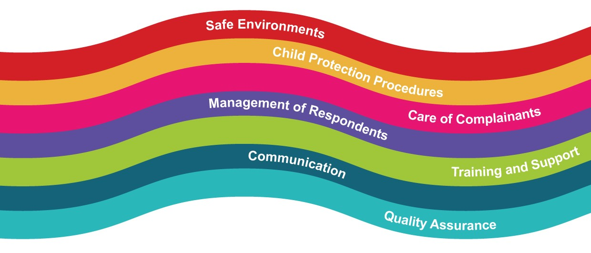

Content | Pages
Section 1 – Vetting Procedures & Declaration Form Guidelines | 3 – 4
Section 2 – Parish groups working with children | 5 - 11
Code of conduct for adults working with children | 5
Code of behaviour for children and young people | 6
Supervision ratios | 7
Dealing with accidents involving children | 8
Complaints procedure | 9
Whistle-blowing procedure | 10
Reporting abuse allegations, suspicions or concerns | 11
Section 3 – Safeguarding Checklists | 12 – 16
Altar Servers | 12
Choir groups involving children | 13
Sacristans | 14
Eucharistic Ministers and Home Visitations Teams | 14
Parish Priest and Curates | 15
Priests from outside the Diocese, including retired Priests | 15
Priests who intend to engage in once off service | 15
Local Safeguarding Representatives | 16
Role of Safeguarding Representatives and Parish Priest | 16
Section 4 – Use of Church Property involving Children | 17
Parish Groups/Activities | 17
Non-Parish Groups/Activities | 17
Schools using Church property for sacramental celebrations | 18
Section 5 – Guide to the Safeguarding Website: What is online? | 18-20
Guidance by Role  - Church personnel ministering with children  - Safeguarding Committee  - Local Safeguarding Representative | 18-19
Safeguarding Forms, Posters & Leaflets | 20
If you have a safeguarding concern or wish to raise a matter from the past please contact:
Marian Stack, Designated Liaison Person
085 1055992 / 053 9122177
In relation to all other Safeguarding queries please contact:
Colette O’Doherty, Safeguarding Co-Ordinator
087-9474513/ 053 9174972

Section 1
Vetting Procedures & Declaration Form Guidelines

Below are the procedures in relation to when is vetting require and who requires vetting. The Garda vetting forms can be found on the Diocesan website under the Safeguarding Section.
Vetting Procedures
When is vetting required?
A person requires vetting when a necessary and regular part of their work consists of the person having access to, or contact with, children and/or adults who may be vulnerable.
Vetting is not necessary when contact with children and/or adults who may be vulnerable is merely incidental to their work or activity.
Who requires vetting?
- All Priests ministering in the Diocese.
- Retired Priests who engage in occasional ministry in the Diocese.
- Parish Safeguarding Representatives.
- Persons supervising altar servers.
- Sacristans and those using Sacristy on regular basis.
- Leaders of groups that involve children.
- Eucharist Ministers visiting adults living alone or in nursing homes.
- Parish Home Visitation Teams visiting adults living alone or in nursing homes.

How to apply for vetting:
Part 1: Proof of identity
- Download, print and complete Vetting Invitation Form (available on www.ferns.ie )
  - Vetting Invitation Form (NVB1)
  - Garda Vetting Form (NVB2) to be accompanied by Diocesan Information Form (the NVB2 is for applicants who do not have an email address)
  - Parent/Guardian Consent Form (for use by under 18’s who are applying for eVetting)

- Bring completed form along with appropriate identification to your local Parish Priest. Appropriate identification is listed on page two of the Vetting Invitation Form.
- Parish Priest will photocopy identification and vetting form and store both securely .
- Parish Priest will sign and post original form to Diocesan Office.

Part 2: Complete email application
- You will receive an email from the Vetting Office, please check your junk mail, occasionally the email will appear here
- Follow instructions in the email, you will be asked to enter the following: Place of birth; passport number; mother’s maiden name; and previous addresses.

Part 3: Vetting approval
- Once vetting is complete the Parish Priest will receive an email notification of the vetting outcome.

Declaration Form Procedures

Who is required to fill in a Declaration Form?
- All Priests/volunteers/staff who are required to fill out a vetting form must also fill in a Declaration Form.
- Readers
- All Eucharistic Ministers
- Collectors
- Committee Members
- All other Church volunteers not listed above.

Section 2
Parish Groups Working with Children
Codes of conduct are essential for effective safeguarding practice. It is important to carefully read these guidelines and follow them at all times. The Code of Conduct for the Diocese of Ferns can be downloaded directly from the Ferns website www.ferns.ie and is displayed within all Church porches and with Church Halls and reads as follows:

Code of Conduct for Clergy, Staff & Volunteers Working with Children & Young People

It is important for all personnel to:
- Treat all children and young people with respect and dignity.
- Be visible to others when working with children/young people.
- Clergy, staff and volunteer workers should never plan to be alone in a building, car or a closed room with a child or young person. If one to one contact takes place in an emergency, inform the parent and make a written record of the matter.
- Providing accommodation in the parochial house for minors is prohibited except in the case of family members or children/young people accompanied by parents or guardians. When the need for a visit to the home of a child/young person arises, professional boundaries must be observed at all times.
- Written consent must be obtained from parents/guardians before organising activities for children/young people in your care.
- Particular care should be taken to ensure that the privacy of children/young people is respected in places such as swimming pools, showers, toilets and changing rooms.
- Avoid spending excessive time alone with children/young people, away from others.
- All organised trips require careful planning and adherence to supervision ratios.
- Do not take photographs of children/young people while they are in changing areas (eg. A locker room or bathing facility). Parental consent for taking photographs must always be sought.
- Use only age appropriate language, media products and activities when working with children and young people. Sexually explicit materials or language are never appropriate.
- Under no circumstances give alcohol, tobacco or drugs to children or young people.
- The physical integrity of children and young people must be respected at all times. Sexual relationships, physical punishments, emotional or verbal abuse are not permitted under any circumstances.
- Ensure that the buildings and/or facilities used for activities with children and /or young people are suitable, safe and secure.

Code of Behaviour for Children and Young People
Children should be involved in drawing up a code of behaviour for themselves; however, it is important that in working with children, an appropriate adult with relevant skills and competencies participates to support them in developing the code of behaviour.
The methods used in creating a code of behaviour should be age and ability appropriate, with children being encouraged to avoid merely drawing up a list of prohibitions. Instead, the code should be comprised of positive statements about respect, and should consider what consequences ensue if the code is broken.
There is online support entitled Workshop on Creating a Code of Behaviour with Children which can be downloaded from the Ferns Website. When developing the code, consideration should be given to the following:

- Treating everyone with respect.
- Treating property with respect.
- Not consuming alcohol, tobacco or illegal drugs.
- Agreeing not to bring any physical item into the Church activity that may cause offence or harm to others.
- Acting as a good role model.
- Attending activities on time.
- Signing in and out.
- Turning off your mobile phone.
- Telling someone you trust if you feel uncomfortable with any situation or individual.
- Not using bad language.
- Never bullying anyone or sending threatening messages.

Note: Please find brochure online on the Diocesan website entitled ‘Leaflet: Safeguarding Information for Parents/Guardians’ which provides codes of behaviours for adults and children as well as a copy of the complaints procedure.

Supervision Ratios
It is recommended that a certain number of adults be available to supervise a certain number of children; however, this is also dependent on whether the children have specific needs or requirements, and on the duration of the activity. At a minimum, two adults are always required for each activity.
Within each group the ratio of adults to children is determined by the age of the children involved:
- 0-1 year: one member of staff to three children
- 1-2 years: one member of staff to five children
- 2-3 years: one member of staff to six children
- 3-6 years: one member of staff to eight children
- 7-12 years: one member of staff to eight children
- 13-18 years: one member of staff to ten children

In addition, for overnight activities additional staff should be considered. If the group is mixed, a gender balance should be maintained.

Dealing with Accidents Involving Children

A form has been developed which is available on the Diocesan website entitled ‘Form for Dealing with Accidents/Incidents’. The form provides a template for gathering necessary information.

If a child has an accident and injures himself/herself while attending a Church-run event, these procedures should be followed:
- Assess the injury and reassure the child. If the injury is severe or the child has lost consciousness, please contact the emergency services
- If the emergency services are called, contact with the child’s parents/guardians must be made urgently. Contact information should be found on the child’s membership/consent form
- If the parents/guardians are not available, it may be necessary for a leader to travel with the child to the hospital. If medical treatment is required, Church personnel may be asked about known allergies or existing medical conditions. Again, this information should be found on the child’s membership/consent form
- If the injury is minor, local application of treatment should be available from the first-aid box. There should be a fully stocked first-aid box to hand at all Church-related events. Remember to make a note of what has been used from the first-aid box so that it can be replaced at the earliest opportunity. Under no circumstances should any medication be given to a child, unless under parental or medical supervision
- As soon as possible after the accident, write up a report using an accident/incident report form (form 9, available on the Diocesan website). Once completed, this form should be stored in a safe place, in line with data protection, and treated as a confidential document
- Always inform parents/guardians of any accident that has occurred involving their child, regardless of how minor you consider it to be. It is good practice to give a copy of the accident/incident report form to parents/guardians
- It is good practice to keep blank copies of the accident/incident form with the first-aid box so that one can be easily filled out in the event of an emergency

Complaints Procedure
A complaint is defined as a grievance and/or the raising of a concern about breaches of codes of behaviour. Allegations or suspicions of child abuse do not fall into this category of general complaints.
All complaints will be taken seriously and dealt with fairly and confidentially. Efforts will be made to quickly and informally resolve complaints through discussion with the parents/guardians, children/young people, volunteers/members of staff and clergy, as appropriate.
If a parent/guardian, young person or child is not satisfied with any aspect of the running of a particular activity, or the behaviour of any individual involved in that activity, the following steps should be taken: All complaints of this nature should be resolved using an open dialogue with the person responsible for the group or the Parish Priest. If resolution is not possible, the following step should be taken.
Please find brochure online on the Diocesan website entitled ‘Leaflet: Safeguarding Information for Parents/Guardians’ which provides codes of behaviours for adults and children as well as a copy of the complaints procedure.
Steps to take:
- Complete complaint form and submit to the Parish Priest.
- A letter acknowledging receipt of the complaint will be sent, enclosing a copy of the complaints procedure. All complaints must be thoroughly investigated.
- The Parish Priest may organise a meeting to discuss and hopefully resolve the complaint.
- Following the meeting or discussion, the Parish Priest will write to the complainant to confirm what took place and to set out any solutions that were agreed upon.
- If a meeting is not agreeable or possible, the Parish Priest will issue a detailed written reply to the complainant, setting out their suggestions for resolving the matter.
- If the complainant is still not satisfied at this point, they should contact the Parish Priest again. At the conclusion of this step, the Bishop may decide to take further action on the complaint.

Whistle-blowing Procedure

All staff and volunteers must acknowledge their individual responsibility to bring matters of concern to the attention of their supervisor/superior/manager.

Reasons for whistle-blowing:
- Each individual has a responsibility to raise concerns about unacceptable practice or behaviour
- To prevent the problem worsening or widening
- To protect or reduce risks to others
- To prevent yourself from becoming implicated

It is important to undertake the following steps:
- Voice any concerns, suspicions or uneasiness as soon as possible. The earlier a concern is expressed the sooner and easier action can be taken.
- Try to pinpoint exactly what practice is of concern and why.
- Approach your immediate superior/supervisor/manager.
- If your concern is about your immediate superior/supervisor/manager, please contact your Parish Priest or the Diocesan Office.
- Make sure a satisfactory response is secured – don’t let matters rest.
- Ideally, concerns should be placed in writing, outlining the background and history, giving names, dates, locations and any other relevant information.
- You are not expected to prove the truth of your complaint, but you need to demonstrate sufficient grounds for concern.

Reporting Abuse Allegation, Suspicion or Concern
- The Diocese of Ferns provides guidance and training on recognition of abuse, and clear procedures on what to do when a child protection concern arises, so that everyone knows how to respond appropriately
- This involves knowing who to tell and how to record it. It is important that the local reporting procedures are fully consistent with statutory legislation, regulations and guidance
- Reporting a concern can be a challenging responsibility. The procedure needs to ensure that everyone is clear what steps to take to ensure that the safety of children is the paramount consideration
- The reporting flow chart below refers to any child protection concern, including where the concern is about a situation or person involved in the Church. It is the responsibility of everyone in the Church to ensure that children who may need help and protection are not left at risk of abuse
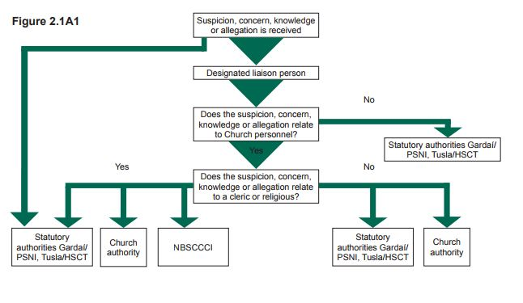

If you have a safeguarding concern or wish to raise a matter from the past please contact:
Marian Stack, Designated Liaison Person
085 1055992 / 053 9122177
In relation to all other Safeguarding queries please contact:
Colette O’Doherty, Safeguarding Co-Ordinator
087-9474513/ 053 9174972

Section 3
Safeguarding Checklists
This section provides you with a safeguarding checklist for some of the key areas of parish work with children.

Altar Servers
When is it necessary for altar servers to be supervised?
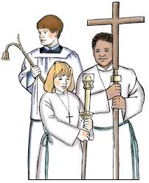
If altar servers are required to get ready in a private setting, for example, the sacristy then supervision is required.
If altar servers get ready in public view of the congregation supervision is not required.
Options for the supervision of altar servers
As with other supervision ratios two adults should be present, both of whom must be vetted.
- Parents of altar servers who have been vetted by the Diocese
- Any adult who has been vetted by the Diocese
- Members of other church groups who have been vetted
- Parish Safeguarding Representatives

- Checklist for persons supervising altar servers

- Vetting approval (requirement to renew vetting every 5 years)
- Confidential Declaration Form
- Induction Agreement Form
- Code of Behaviour for Adults Working with Children and Young People
- Role Description

- Checklist for parents of altar serving children

- Media Permission Form
- Child and Guardian Joint Consent Form
- Young people aware of appropriate code of behaviour
- Leaflet: Safeguarding Information for Parents/Guardians
- Attend annual information session for parents and children

Choir Groups Involving Children
Who requires vetting for choir groups?
The leader(s) of the choir group require vetting.

- Checklist for Choir Leaders

- Confidential Application Form
- Vetting approval (requirement to renew vetting every 5 years)
- Confidential Declaration Form
- Induction Agreement Form
- Code of Behaviour for Adults Working with Children and Young People
- Induction for new personnel in this position
- Safeguarding Training (renew training every 3 years)
- Attendance register for Choir
- Provide annual information session for parents and children

- Checklist for parents / guardians whose children are in the Choir

- Media Permission Form
- Child and Guardian Joint Consent Form
- Young people aware of appropriate code of behaviour
- Leaflet: Safeguarding Information for Parents.
- Attend annual information session for parents and children

Mixed Choir (where there are both adult and children choir members)
The leader(s) of the choir group require vetting. All other adult members of the choir require Declaration Forms.

Sacristans

- Checklist for Sacristans

- Application Form
- Vetting approval (requirement to renew vetting every 5 years)
- Confidential Declaration Form
- Code of Behaviour for Adults Working with Children and Young People
- Induction Agreement Form
- Induction for new personnel in this position
- Safeguarding Training

Eucharistic Ministers/Home Visitation Teams
- Checklist for Eucharistic Ministers/Home Visitation Teams visiting adults living alone or in nursing homes

- Vetting approval (requirement to renew vetting every 5 years)
- Confidential Declaration Form
- Code of Behaviour for Adults Working with Children and Young People
- Induction Agreement Form
- Induction for new personnel in this position
- Attend Safeguarding Training

Parish Priests & Curates

The Parish Priest has the overall responsibility for safeguarding children and vulnerable adults. In this capacity, the Parish Priest is supported by the Safeguarding Representatives and the Diocesan Safeguarding Co-ordinator.
- Checklist for Parish Priests & Curates

- Vetting approval (requirement to renew vetting every 5 years)
- Confidential Declaration Form
- Code of Behaviour for Adults Working with Children and Young People
- Induction Agreement Form
- Attend full-day Safeguarding Training (renew training every 3 years)

Visiting Priests: Priests from outside the Diocese, including retired Priests
- Checklist for Priests from outside the diocese who intend to minister for short or long periods of time

- Seek permission of the Bishop: Details about the duration of the visit, the type of ministry and the location of ministry being considered
- Confirmation of good standing must be completed and submitted to Bishop.
- Complete Garda vetting process
- Confidential Declaration Form
- Code of Behaviour for Adults Working with Children and Young People
- Induction Agreement Form
- Safeguarding Training (renew training every 3 years)

Priest from outside the Diocese : Engaging in once off service
- Checklist for Priest who intend to engage in a once off service

- This applies for occasions like weddings, baptisms and funerals
- A Celebret Card must be produced to the Parish Priest

Local Safeguarding Representatives

Safeguarding Representatives support the Parish Priest in maintaining safeguarding standards in the Parish area. It is recommended that each Parish have two safeguarding Representatives.

- Checklist for safeguarding representatives

- Vetting approval (requirement to renew vetting every 5 years)
- Confidential Declaration Form
- Code of Behaviour for Adults Working with Children and Young People
- Induction Agreement Form
- Induction for new personnel in this position
- Attend Safeguarding Training (renew training every 3 years)

Role of the Safeguarding Representatives and Parish Priest
There is a brochure on the Role of the Rep available online on http://ferns.ie/safeguardingforms/
All groups and personnel that work with children:
All personnel have completed either the full-day Safeguarding Training Programme; Safeguarding Information Session, depending on their role.
Each Rep has received a Brochure on the Role of the Rep and is familiar with the content.
Induction with personnel who work with children is complete.
All relevant safeguarding forms have been understood and completed.
All groups working with children are aware of the safeguarding needs within the group setting.
Ensure Garda Vetting is complete and up-to-date.
Ensure that all parish groups involving children utilise the sign-in / sign-out registers.
Ensure that all non-parish groups fill out the Hall Application Form.
Ensure all Diocesan Posters on Safeguarding are displayed prominently.
Safeguarding Representatives and Parish Priest complete the annual safeguarding audit each year.

Section 4
Use of Church Property involving Children

- Parish Groups/Activities:
A Parish activity is one which is carried out with the full knowledge and authority of and under the control of the clergy or of any other person specifically authorised by them. Parish activities within this definition are covered within the Parish insurance policy. The responsibility for safeguarding rests with the Parish Priest.

Parish Group Activities must:
- Adhere to the Diocese of Fern’s Safeguarding Policy.
- Fully inform the Safeguarding Representative of activities taking place.
- Parish Representatives role is to ensure that the activities adhere to the Diocesan Safeguarding Policies.

- Non- Parish Groups/Activities:
An Outside Group is one which does not fall under the definition of the parish activities. The Parish Representative has no role in relation to these activities.

Non-Parish Group/Activities must:
- Have their own separate insurance arrangements in place to cover their own separate legal liability. Allianz is the insurance company for the Parish and would be pleased to offer quotations to such outside groups or persons.
- Have a Children’s Safeguarding Policy in place (which includes Vetting).
- Complete the Parish Hall Application Form for Non-Parish Activities.
- Ensure that the Parish Priest approves the activity.

Long term Letting/Leasing Arrangements by Outside Group:
Where a part of the hall is let exclusively e.g. to a pre-school playgroup or local community organisation, such letting should be by way of a formal agreement. The Parish Representative has no role in relation to these activities.

Non-Parish Group/Activities must:
- Have their own separate insurance arrangements in place to cover their own separate legal liability. A procedure should be put in place to request the letter of confirmation near the expiry date of the policy to ensure a continuation of the insurance. Where the letting is for over a year the check should be carried out annually.
- Have a Children’s Safeguarding Policy in place (which includes Vetting).
- Complete the Parish Hall Application Form for Non-Parish Activities.
- Ensure that the Parish Priest approves the activity.

Private Function
Individual adults (parents/guardians/family members) approaching the parish priest to use Church property for a private function do not meet the requirement for vetting. It is the sole responsibility of the parents/guardians to organise and supervise all children attending.
Parish Priest must ensure:
- Property is fit for use in terms of health and safety
- Groups using the property are aware of how to report any accidents resulting from the condition of the property

- Schools using Church property for sacramental celebrations
The school and the parish priest need to agree who is responsible for safeguarding in each
circumstance.

Section 5
Guide to the Safeguarding Website: What is online?
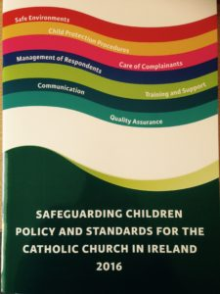

The Ferns Diocesan website, www.ferns.ie, has been updated in line with the

updated standards. It has also been updated to assist you in your role when

working with children.

The safeguarding children policy document is now available to download online.
There is also a concise version of the Safeguarding Policy Document which can
be downloaded also.

Guidance by Role

On this page you can view the relevant pieces of the guidance for each role in the safeguarding structure. This will make it easier to examine only those pieces of guidance which are relevant to your role.

Church personnel ministering with children
1.1A Guidance on Safe Recruitment Procedures
1.2A Guidance on Codes of Behaviour for Adults
1.3A Guidance on Creating a Code of Behaviour with Children
1.3B Guidance on Dealing with Breaches of Codes of Behaviour for Children and Adults
1.3C Guidance on Anti-Bullying
1.4A Guidance on Safe Care for Children
1.4B Guidance on Dealing with Accidents
1.4C Guidance on Maintaining Adequate Supervision Ratios
1.4D Guidance on One-to-One Contact with Children and Young People
1.4E Guidance on the Pope John Paul II Award
1.4F Guidance on the Participation of Children with Specific Needs
1.4G Guidance on Trips Away with Young People
1.6A Guidance on Whistle-Blowing
1.7A Guidance on Complaints Procedure for Safeguarding Concerns that are not Allegations of Abuse
1.8A Guidance on Hazard Assessment of Activities with Children
1.9A Guidance on Use of Technology
1.9B Guidance on Use of the Internet
1.9C Guidance on Use of Texting and Email
1.9D Guidance on Use of Photography
1.9E Guidance on Use of CCTV and Webcams
2.1A Guidance on Reporting Allegations of Abuse
5.5A Guidance on Raising Awareness of Child Safeguarding with Children and their Parents/Guardians
5.6A Guidance on Support and Supervision
6.2A Guidance on Ensuring that Information Regarding the Church’s Child Safeguarding Message is Accessible
6.2B Guidance on Creating User-Friendly Versions of the Child Safeguarding Policy
6.3A Guidance on Communicating Appropriately to those whose First Language is not English, and to those who have Specific Needs
Local Safeguarding Representative
1.1A Guidance on Safe Recruitment Procedures
1.4A Guidance on Safe Care for Children
1.5A Guidance on External Groups who Use Church Property
1.5B Guidance on Church Property and Hire for Private Functions
1.6A Guidance on Whistle-Blowing
1.7A Guidance on Complaints Procedure for Safeguarding Concerns that are not Allegations of Abuse
2.1A Guidance on Reporting Allegations of Abuse
5.6A Guidance on Support and Supervision
6.2A Guidance on Ensuring that Information Regarding the Church’s Child Safeguarding Message is Accessible
6.2B Guidance on Creating User-Friendly Versions of the Child Safeguarding Policy
6.3A Guidance on Communicating Appropriately to those whose First Language is not English, and to those who have Specific Needs

Safeguarding Committee
7.1F Guidance on Developing a Constitution for a Safeguarding Committee
1.1A Guidance on Safe Recruitment Procedures
1.2A Guidance on Codes of Behaviour for Adults
1.3A Guidance on Creating a Code of Behaviour with Children
1.3B Guidance on Dealing with Breaches of Codes of Behaviour for Children and Adults
1.3C Guidance on Anti-Bullying
1.4A Guidance on Safe Care for Children
1.4B Guidance on Dealing with Accidents
1.4C Guidance on Maintaining Adequate Supervision Ratios
1.4D Guidance on One-to-One Contact with Children and Young People
1.4G Guidance on Trips Away with Young People
1.5B Guidance on Church Property and Hire for Private Functions
1.6A Guidance on Whistle-Blowing
1.7A Guidance on Complaints Procedure for Safeguarding Concerns that are not Allegations of Abuse
1.8A Guidance on Hazard Assessment of Activities with Children
1.9A Guidance on Use of Technology
1.9B Guidance on Use of the Internet
1.9C Guidance on Use of Texting and Email
1.9D Guidance on Use of Photography
1.9E Guidance on Use of CCTV and Webcams
2.1A Guidance on Reporting Allegations of Abuse
2.1J Guidance on Cross-Referencing Safeguarding Policies
5.5A Guidance on Raising Awareness of Child Safeguarding with Children and their Parents/Guardians in the Church
5.6A Guidance on Support and Supervision
6.2A Guidance on Ensuring that Information Regarding the Church’s Child Safeguarding Message is Accessible
6.2B Guidance on Creating User-Friendly Versions of the Child Safeguarding Policy

Safeguarding Forms, Posters & Leaflets
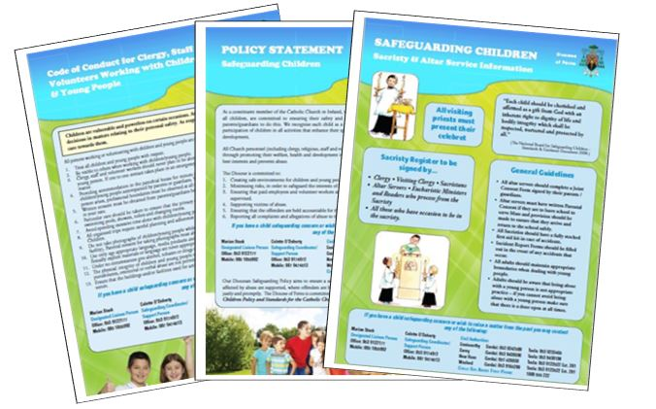
There is a page online for easy access to the most frequently
used forms, posters and leaflets. Below is the list, all of which can be
downloaded for your convenience.

- Parish Self Audit Form 2016
- Parish Self Audit Form 2017
- Application Form
- Attendance Register for Sacristy
- Attendance Register for Large Groups
- Character & Personal Reference Request Form
- Child & Guardian Joint Consent Form
- Confidential Declaration Form
- Confidentiality Declaration Form
- Form for Dealing with Accidents/Incidents
- General Complaints Form
- Guidance for Supervision Ratios
- Guidance on Use of Technology
- Hazard Assessment Form
- Induction Agreement Form
- Leaflet: Safeguarding Information for Parents/Guardians
- Leaflet: Lourdes Safeguarding Information 2016/2017
- Leaflet: Role of the Safeguarding Representative
- Leaflet: Spirit Safeguarding Brochure
- Leaflet: Spirit Information Brochure
- Media Permission Form
- Parish Self Audit Form
- Parish Hall Application Form
- Poster: Code of Conduct for Clergy, Staff & Volunteers
- Poster: Information for Young People
- Poster: Our Local Parish Safeguarding Representative
- Poster: Policy Statement
- Poster: Present Celebrets
- Poster: Safeguarding Poster in Polish
- Poster: Safeguarding Policy in Irish
- Poster: Sacristy & Altar Service Information
- Recruitment & Selection Checklist
- Whistleblowing Policy
- Workshop on Creating a Code of Behaviour with Children
If you have a safeguarding concern or wish to raise a matter from the past please contact:
Marian Stack, Designated Liaison Person
085 1055992 / 053 9122177
In relation to all other Safeguarding queries please contact:
Colette O’Doherty, Safeguarding Co-Ordinator
087-9474513/ 053 9174972

