PARISH INFORMATION DETAILS
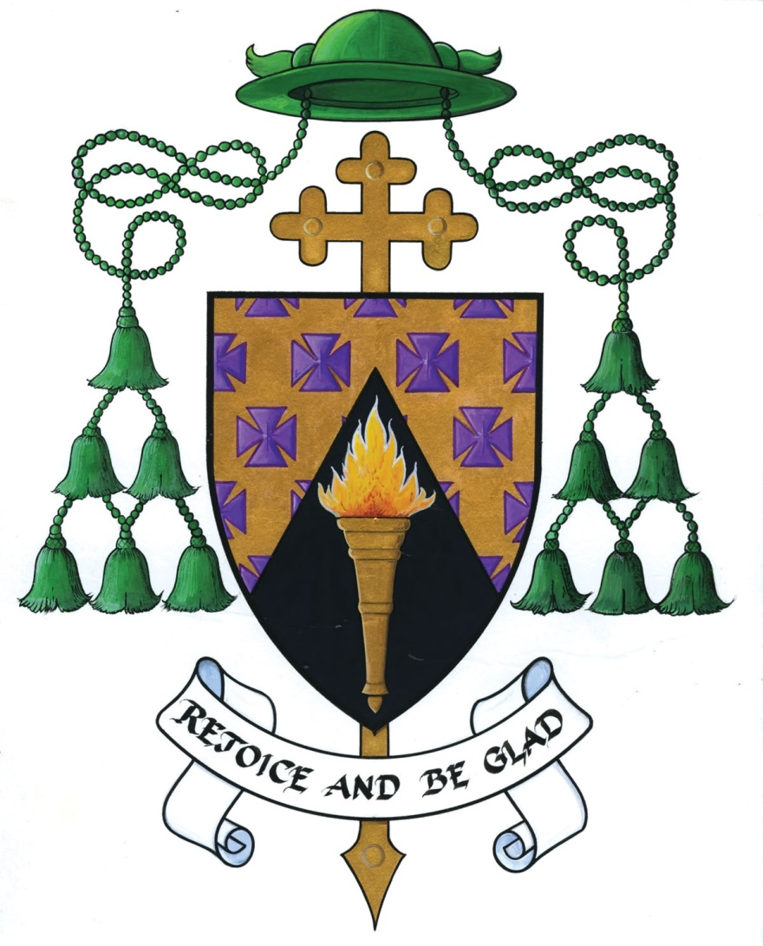

To be completed annually by Parish Priest/Curate along with the Local Safeguarding Representative(s)

NAME OF PARISH:
PERSON(S) COMPLETING AUDIT: | Priest:_______________________________________________________  Rep 1:_______________________________________________________  Rep 2:_______________________________________________________
DATE OF COMPLETION:

Please note all forms in the Relevant Form/Leaflet/Posters section below can be downloaded from www.ferns.ie/safeguardingforms for your convenience

CREATING & MAINTAINING SAFE ENVIRONMENTS
PARISH GROUPS WORKING WITH CHILDREN AND YOUNG PEOPLE | YES | NO | N/A | Relevant Form/Leaflet/Poster
Have parents signed consent forms for children. |  |  |  | Child & Guardian Joint Consent Form
Are you adhering to the Parish Social Networking Policy in relation to the use of photography and internet use? |  |  |  | Media Permission Form  Guidance on Use of Technology
Where applicable Parents must be provided with a copy of the safeguarding policies and procedures. A generic leaflet for parents is on the website entitled ‘Safeguarding Information for Parents/Guardians’ |  |  |  | Leaflet: Safeguarding Information for Parents/Guardians  General Complaints Form
Is each group aware and maintaining adequate supervision ratio? |  |  |  | Guidance for Supervision Ratios
Does each group have access to the procedure for dealing with accidents? |  |  |  | Form for Dealing with Accidents/ Incidents
Is there an official sign in book being used in the Sacristy? (To be used at all times with or without the involvement of altar servers) |  |  |  | Attendance Register for Sacristy
Is there an attendance register completed for each group involving children? |  |  |  | Attendance Register for Large Group
Are all facilities compliant with the Diocesan Health and Safety Statement? |  |  |  | Hazard Assessment Form
Have all visiting Clergy been asked to provide Celebrets/evidence that they are in good standing? |  |  |  | Poster: Present Celebret
Are all safeguarding forms stored securely?
NON-PARISH GROUPS WORKING WITH CHILDREN USING CHURCH PROPERTY. | YES | NO | N/A | Relevant Form/Leaflet
Have all non-parish groups working with children signed the Hall Application Form? |  |  |  | Parish Hall Application Form
Do all non-Parish Groups using Parish facilities have Safeguarding Policies (of which vetting is part of it) and Insurance? |  |  |  | Parish Hall Application Form

Recruitment of personnel to work with children/vulnerable adults (Choir leaders, youth leaders, pastoral home visits, etc. | YES | NO | N/A | Relevant Form/Leaflet
Clear job descriptions are provided? |  |  |  | Recruitment & Selection Checklist
Application forms are completed? |  |  |  | Application Form
References are sought and checked? |  |  |  | Character & Personal Reference Request Form
Vetting is completed (if appropriate)? |  |  |  | Garda Vetting Forms
Declaration forms are completed? |  |  |  | Confidential Declaration Form
The National Safeguarding Policy and Guidance can be sourced online on http://ferns.ie/policyandstandards. Please tick to indicate you have noted same. |  |  |  | National Safeguarding Policy Document and Guidance Document
A whistle-blowing policy has been provided? |  |  |  | Whistleblowing Policy

COMMUNICATING THE CHURCH’S SAFEGUARDING MESSAGE
This includes publications developed nationally and locally for each Parish. | YES | NO | N/A | Relevant Form/Leaflet
Have all Church personnel signed an Induction Agreement Form to show that they have read the policy and procedures? |  |  |  | Induction Agreement Form
Have all Local Safeguarding Reps been provided with ‘The Role of the Safeguarding Representative’ leaflet? |  |  |  | Leaflet: Role of Safeguarding Representative
Is the Diocesan Safeguarding Policy Statement displayed prominently within the Church? |  |  |  | Poster: Policy Statement
Is the Diocesan Code of Conduct for Clergy, Staff & Volunteers Working with Children & Young People displayed prominently within the Church? |  |  |  | Poster: Code of Conduct for Clergy, Staff & Volunteers
Is the Information for Young People poster displayed prominently and appropriate for children? |  |  |  | Poster: Information for Young People
Is the Poster requesting Celebrets from all visiting Clergy displayed prominently? |  |  |  | Poster: Present Celebrets
Is the Sacristy & Altar Service Information Poster displayed prominently in the Sacristy? |  |  |  | Poster: Sacristy & Altar Service Information Poster
Are the contact details for the Local Safeguarding Representatives displayed prominently in the Church? |  |  |  | Poster: Your local Parish Safeguarding Representative
If you have groups in your local area whose first language is not English, do you have copies of the safeguarding message in accessible formats. |  |  |  | Poster: Safeguarding Policy in Polish  Poster: Safeguarding Policy in Irish
Do you provide the contact details for the Local Safeguarding Representative in your parish newsletter at least 4 times a year? |  |  |  | Poster: Our local Parish Safeguarding Representative

Signed: ___________________________________ Signed: ___________________________________
(Priest) (Safeguarding Rep 1)
Signed: ___________________________________
(Safeguarding Rep 2)

