PARISH INFORMATION DETAILS
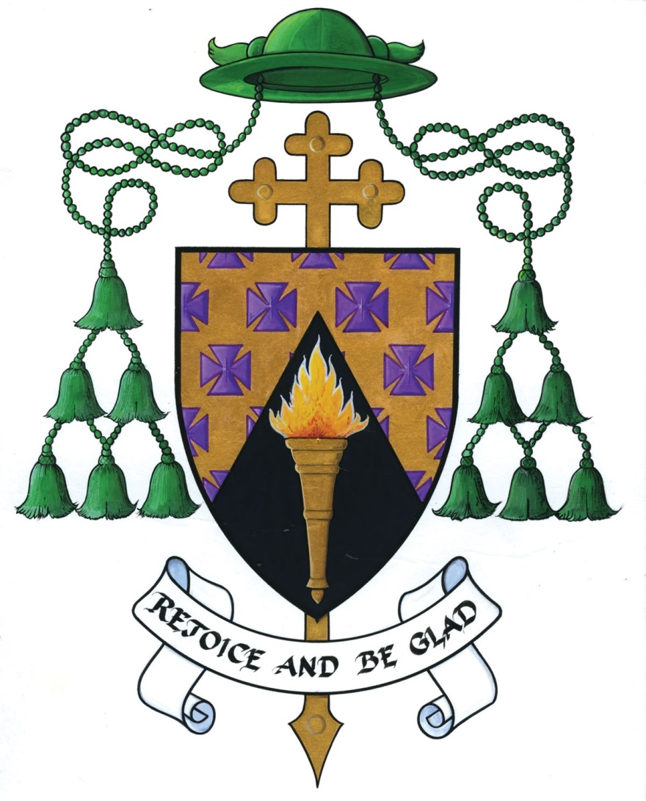

To be completed annually by Parish Priest/Curate along with the Local Safeguarding Representative(s)

NAME OF PARISH:
PERSON(S) COMPLETING AUDIT: | Priest:_______________________________________________________  Rep 1:_______________________________________________________  Rep 2:_______________________________________________________
DATE OF COMPLETION:

Please note all forms in the Relevant Form/Leaflet/Posters section below can be downloaded from www.ferns.ie/safeguardingforms for your convenience

CREATING & MAINTAINING SAFE ENVIRONMENTS
PARISH GROUPS WORKING WITH CHILDREN AND YOUNG PEOPLE e.g Altar Servers, Parish Youth Groups, Summer Camps, John Paul II Awards etc. | YES | NO | All Forms/Leaflets/Posters  And Guidance found on ferns.ie/safeguardingforms
Have parents signed consent forms for children.  (In future both child and parent must sign a Joint Consent Form.) |  |  | Child & Guardian Joint Consent Form
Are you adhering to the Parish Social Networking Policy in relation to the use of photography and internet use?  (If applicable, parents/guardians and children must sign a Media Permission Form) |  |  | - Media Permission Form  - Guidance on Use of Technology
Where applicable Parents must be provided with a copy of the safeguarding policies and procedures. A generic leaflet for parents is on the website entitled ‘Safeguarding Information for Parents/Guardians’ |  |  | - Leaflet: Safeguarding Information for Parents/Guardians  - General Complaints Form
Is each group aware and maintaining adequate supervision ratio? |  |  | Guidance for Supervision Ratios
Does each group have access to the procedure for dealing with accidents? |  |  | Form for Dealing with Accidents/ Incidents
Is there an official sign in book being used in the Sacristy? (To be used at all times with or without the involvement of altar servers) |  |  | Attendance Register for Sacristy
Is there an attendance register completed for each group involving children? |  |  | Attendance Register for Large Group
Are all facilities compliant with the Diocesan Health and Safety Statement? |  |  | Hazard Assessment Form
Have all visiting Clergy been asked to provide Celebrets/evidence that they are in good standing? |  |  | Poster: Present Celebret
Are all safeguarding forms stored securely?
NON-PARISH GROUPS WORKING WITH CHILDREN USING CHURCH PROPERTY. | YES | NO | Relevant Form/Leaflet
Have all non-parish groups working with children signed the Hall Application Form? |  |  | Parish Hall Application Form
Do all non-Parish Groups using Parish facilities have Safeguarding Policies (of which vetting is part of it) and Insurance? |  |  | Parish Hall Application Form
RECRUITMENT: Recruitment of personnel to work with children/vulnerable adults | YES | NO | Relevant Form/Leaflet
Clear job descriptions are provided? |  |  | Recruitment & Selection Checklist
Application forms are completed? |  |  | Application Form
References are sought and checked? |  |  | Character & Personal Reference Request Form
Vetting is completed (if appropriate)? |  |  | Garda Vetting Forms
Declaration forms are completed? |  |  | Confidential Declaration Form
The National Safeguarding Policy and Guidance can be sourced online ferns.ie/policyandstandards. Please tick to indicated you have noted same. |  |  | National Safeguarding Policy Document and Guidance Document
A whistle-blowing policy has been provided? |  |  | Whistleblowing Policy
COMMUNICATING THE CHURCH’S SAFEGUARDING MESSAGE
This includes publications developed Nationally and locally for each Parish. | YES | NO | Relevant Form/Leaflet
Have all Church personnel been shown the Safeguarding Manual as part of an induction process? |  |  | From here on in it can be found online entitled ‘National Safeguarding Policy Document’
Have all Church personnel signed an Induction Agreement Form to show that they have read the policy and procedures? |  |  | Induction Agreement Form
Have all Local Safeguarding Reps been provided with ‘The Role of the Safeguarding Representative’ leaflet? |  |  | Leaflet: Role of Safeguarding Representative
Is the Diocesan Safeguarding Policy Statement displayed prominently within the Church? |  |  | Poster: Policy Statement
Is the Diocesan Code of Conduct for Clergy, Staff & Volunteers Working with Children & Young People displayed prominently within the Church? |  |  | Poster: Code of Conduct for Clergy, Staff & Volunteers
Is the Information for Young People poster displayed prominently and appropriate for children? |  |  | Poster: Information for Young People
Is the Poster requesting Celebrets from all visiting Clergy displayed prominently? |  |  | Poster: Present Celebrets
Is the Sacristy & Altar Service Information Poster displayed prominently in the Sacristy? |  |  | Poster: Sacristy & Altar Service Information Poster
Are the contact details for the Local Safeguarding Representatives displayed prominently in the Church? |  |  | Poster: Your local Parish Safeguarding Representative
If you have groups in your local area whose first language is not English, do you have copies of the safeguarding message in accessible formats. |  |  | Poster: Safeguarding Policy in Polish  Poster: Safeguarding Policy in Irish
Do you provide the contact details for the Local Safeguarding Representative in your parish newsletter at least 4 times a year? |  |  | Poster: Our local Parish Safeguarding Representative
AUDIT OF PERSONNEL FOR TRAINING PURPOSES

Training will take place for all church personnel paid/voluntary as all persons are to be informed in the policy and procedures of safeguarding children/vulnerable adults. To get an indication of numbers for each parish, I would be obliged if you could complete the following table.

Parish:_________________________________

Role within Parish | Numbers of persons in this role | Declaration Form Signed | Vetting Completed
Sacristan
Eucharistic Ministers
Eucharistic Ministers (home visits)
Youth Leaders
Choir Leaders
Parish Home Visitation Team
Parish Bereavement Team
Church Volunteers i.e. readers, collectors, cleaners, etc.
Pastoral Committee
Finance Committee
Working with Altar Servers
Other roles (please list below)

AUDIT OF PARISH ACTIVITIES FOR YOUNG PERSONS/VULNERABLE ADULTS

The Diocese of Ferns values and encourages the participation of children/vulnerable adults in all activities that enhance their spiritual, physical, emotional, intellectual and social development. In order for us to support same can you please tick opposite which of the following activities with young people takes place in your parish.

Parish:_________________________________
Name of Activity | Please tick
Altar Servers
Parish Youth Group
Youth Readers
Summer Youth Camps
Youth Participation on Pastoral Committee
Sunday School
You shall be my Witness Programme
Do this in Memory of me Programme
Junior Choir
Mixed Choir (adults & children)
Family Mass
Other activities please list below:
LIST OF AGENCIES AND LAY APOSTOLATES

The National Safeguarding Office is seeking a list of all agencies and apostolates with ministry to young people within the Diocese please keep a copy of same:

Parish:_________________________________

Name of Group | Key Contact Person | Contact Number
St Vincent De Paul
Children of the Eucharist
FDYS
Pioneers
Legion of Mary
Net Ministries
Trocaire
Youth 2000
Alpha Group
Dead Theologians Society
Jesus Youth
Scripture Union Ireland
Nua
Other (please specify)

LIST OF SUPPLY PRIESTS/VISITING PRIESTS

The Diocese of Ferns requires a list of all priests who provide assistance to you as supply. This can be priest of the diocese or indeed visiting priests from other Diocese who visit yearly or periodically. Please note all priests must present their Celebret before ministering.

Parish:_________________________________

Name of Priest & Contact Number | Priests Diocese | Comment/Note

